

Final Year Project Report

**PakWork**

Project Team:

Asaad Noman Abbasi (1912297)

Muhmmad Ahsan (1912310)

Project Supervisor:

Muhammad Shahzad Haroon

Date: 9th November 2022

Submitted in partial fulfillment of the requirements for the degree of

Bachelor of Science in Computer Science

in the

Faculty of Computing and Engineering Sciences

Shaheed Zulfikar Ali Bhutto Institute of Science and Technology

(SZABIST)

Karachi Campus

# PLAGRISIM FREE CERTIFCATE

This is to certify that, I am Asaad Noman Abbasi S/D/O Noman Abbasi groupleader of FYP under

Date: ____________________

Name of Group Leader _________________________________

Signature _______________

Name of Supervisor _______________________

Designation ______________________________

Signature ________________________________

**Declaration of Authorship**

We, Asaad Noman (1912297) and Muhammad Ahsan (1912310), declare that this report titled, “PakWork” and the work presented in it are our own. We confirm that: This work was done wholly or mainly while in candidature for a bachelor’s degree at this University. Where any part of this report has previously been submitted for a degree or any other qualification at this University or any other institution, this has been clearly stated. Where we have consulted the published work of others, this is always clearly attributed. Where we have quoted from the work of others, the source is always given. With the exception of such quotations, this report is entirely our own work. We have acknowledged all main sources of help. Where the report is based on work done by us jointly with others, we have made clear exactly what was done by others and what we have contributed ourselves.

Signed: Asaad Noman (1912297), Muhammad Ahsan (1912310)

Date: 9th November, 2022

**Project Description**

We aim to create a platform that targets freelancers with much easier policies and regional service charges. On the other hand, to tackle the issue of unprofessional and unskilled freelancers, we aim to provide a customized filtering process to ensure that only professional and skilled freelancers can be allowed to work on the platform. We also provide a customized test related to the job that is being bided by freelancers so that only matched freelancers can bid on outsourced projects by businesses, as this way we can tackle much of the filtering part we can offer to the clients. To tackle the issue of the order policy we will make sure that the freelancer has the choice to accept or decline customer job offers made by the client.

Keywords: Freelancing, Freelancing Platform, Outsourcing, Gigs

**Acknowledgment**

In the name of ALLAH, the most beneficent and merciful who gave us the knowledge and courage to work on this research area. The success and final outcome of this project required a lot of guidance and assistance from many people and we are extremely privileged to have got this all along the completion of our project. We would first like to thank our supervisor “Sir Shahzad Haroon” of the Computer Science faculty at Shaheed Zulfiqar Ali Bhutto Institute of Science and Technology. The door to his office was always open whenever we ran into a trouble spot or had a question about our project or documentation. He consistently helped, cooperated and motivated us throughout the research. We would like to thank to our teachers who guided us in the light of their knowledge and experience. We would also like to express our gratitude to our loving parents and family members who helped and gave us encouragement. Furthermore, we would also like to acknowledge with much appreciation the crucial role of the staff of SZABIST, who gave the permission to use all required equipment and the necessary materials to complete the project. At the end, we would like to thank Shaheed Zulfiqar Ali Bhutto Institute of Science and Technology for providing us such an inspiring environment. The quality education, the cooperative faculty members and the challenging environment have always motivated and boosted the confidence level of each and every student who has been a part of Shaheed Zulfiqar Ali Bhutto Institute of Science and Technology. And many thanks to all those who let us share their knowledge and resources.

Table of Contents

Table of Contents 7

Revision History 9

Iteration Plan 7

FYP Project Proposal 10

1. Introduction 11

2. Objective 11

3. Problem Description 11

4. Methodology 11

5. Project Scope 12

6. Feasibility Study 12

7. Solution Application Areas 12

8. Tools/Technology 12

9. Expertise of the Team Members 16

10. Milestones 13

11. Project Schedule 14

12. Work Breakdown Structure 14

13. References 22

Software Requirements Specification 23

1. Introduction 24

1.1 Purpose 24

1.2 Document Conventions 24

1.3 Intended Audience and Reading Suggestions 24

1.4 Product Scope 24

1.5 References 24

2. Overall Description 24

2.1 Product Perspective 24

2.2 Product Functions 25

2.3 User Classes and Characteristics 25

2.4 Operating Environment 26

2.5 Design and Implementation Constraints 26

2.6 User Documentation 26

2.7 Assumptions and Dependencies 26

3. External Interface Requirements 26

3.1 User Interfaces 26

3.2 Hardware Interfaces 30

3.3 Software Interfaces 30

3.4 Communications Interfaces 30

4. System Features 30

4.1 Freelancer Registration / Verification System 31

4.2 Gig / Job Creating & Posting 33

4.3 Profile Dashboard 35

4.4 Search System 37

4.5 Buyer Requests 39

4.6 Order Management 40

4.7 Custom Offers 42

4.8 Bidding System 43

4.9 Push Notification System 44

4.10 Chat System 46

4.11 Rating/Feedback System 47

4.12 Personalized Testing System 48

5. Other Nonfunctional Requirements 50

5.1 Performance Requirements 50

5.2 Safety Requirements 50

5.3 Security Requirements 50

5.4 Software Quality Attributes 50

5.5 Business Rules 50

6. Other Requirements 50

Appendix A: Glossary 51

Appendix B: Analysis Models 51

ERD: 51

System Use Case Diagram: 52

Domain Model: 53

Appendix C: To Be Determined List 54

Testing Documents 55

Diagrams 70

**1. System Sequence Diagrams** 68

1.1. Freelancer Registration / Verification 68

1.2. Gigs / Job Posting 68

1.3.Profile Dashboard 69

1.4.Search System 69

1.5.Buyer Requests 70

1.6.Order Management 70

1.7.Custom Offers 71

1.8.Bidding Sysetm 71

1.9.Push Notification System 72

1.10.Chat System 72

1.11 Rating/Feedback System 73

1.12.Personalized Testing System 73

Software Design Specification 74

1. Introduction 75

1.1 Purpose of this document 75

1.2 Scope of the development project 75

1.3 Definations, acronyms and abbrieviation 75

1.4 References 75

1.5 Overview of document 76

2. System architecure description 76

2.1 Section overview 76

2.2 General Constraints 76

2.3 Data Design 78

2.4 Program Structure 78

2.5 Alternatives Considered 79

3. Detailed description of components 79

3.1 Section overview 79

3.2 Component of Gigs & Job Feature 79

3.3 Component of Order Management and Rating/Feedback 80

4. User Inteface Design 81

4.1 Section overview 82

4.2 Interface Design Rules 82

4.3 GUI Components 82

4.4 Detailed Description 82

5. Reuse and relationships to other products 82

6. Design decision and tradeoffs 82

7. Psudeo for components 82

8. Appendices 83

8.1 Class Diagram 83

8.2 Object Diagram 84

8.3 Statechart Diagram 85

8.4 Activity Diagram 86

8.5 Sequence Diagram 93

8.6 Collabration Diagram 93

8.7 Use Case Diagrams 93

8.8 Component Diagram 93

8.9 Deployment Diagram 94

8.10 System Block Diagram 94

**9. User Manual………………………………………………………………………….………95**

**10. Meeting Log Sheet…………………………………………………………………………107**

Revision History

|  |  |  |  |
| --- | --- | --- | --- |
| **Name** | **Date** | **Reason For Changes** | **Version** |
| Asaad | 10th Jan 2023 | Revision for final | 1.1 |
|  |  |  |  |

# Iteration

# Plan

|  |  |  |  |  |  |
| --- | --- | --- | --- | --- | --- |
| **PakWork Iteration Plan** | | | | | |
|  |  |  |  |  |  |
| **S.No.** | **Features** | **FYP-I Iterations** | | | |
| **Monthly Iteration-I** | **Monthly Iteration-II** | **Monthly Iteration-III** | **Monthly Iteration-IV** |
| F1 | Freelancer Registration & Verification System | Requirements |  |  |  |
| Design |  |  |  |
|  | Implementation |  |  |
|  | Testing |  |  |
| F2 | Client Registration System | Requirements |  |  |  |
| Design |  |  |  |
|  | Implementation |  |  |
|  | Testing |  |  |
| F3 | Profile Dashboard | Requirements |  |  |  |
| Design |  |  |  |
|  | Implementation | Implementation |  |
|  |  | Testing |  |
| F4 | Jobs / Gigs Posting | Requirements |  |  |  |
|  |  | Design |  |
|  |  | Implementation |  |
|  |  |  | Testing |
| F5 | Order Management | Requirements |  |  |  |
|  |  |  |  |
|  |  | Design |  |
|  |  | Implementation | Testing |
| F6 | Buyer Requests | Requirements |  |  |  |
|  |  |  |  |
|  |  | Design |  |
|  |  | Implementation | Testing |
| F7 | Search System | Requirements |  |  |  |
|  |  |  |  |
|  |  | Design |  |
|  |  | Implementation | Testing |
| **S.No.** | **Features** | **FYP-II Iterations** | | | |
| **Monthly Iteration-I** | **Monthly Iteration-II** | **Monthly Iteration-III** | **Monthly Iteration-IV** |
| F8 | Bidding System | Requirements |  |  |  |
| Design |  |  |  |
| Implementation | Implementation |  |  |
|  | Testing |  |  |
| F9 | Push Notifications | Requirements |  |  |  |
| Design |  |  |  |
|  | Implementation |  |  |
|  | Testing |  |  |
| F10 | Custom Offers | Requirements |  |  |  |
| Design |  |  |  |
|  | Implementation |  |  |
|  | Testing |  |  |
| F10 | Chat System | Requirements |  |  |  |
|  | Design | Design |  |
|  |  | Implementation | Implementation |
|  |  |  | Testing |
| F11 | Rating & Feedback System | Requirements |  |  |  |
|  |  | Design |  |
|  |  | Implementation |  |
|  |  |  | Testing |
| F11 | Personalized Testing Systems | Requirements |  |  |  |
|  |  | Design |  |
|  |  | Implementation |  |
|  |  |  | Testing |

# FYP Project Proposal

# Introduction

A Freelancing platform for freelancers. Where freelancers can easily sell their gigs and offer services to potential clients/businesses. We aim to provide a fully featured platform that provides everything necessary for a seamless process of a transaction between two entities.

# 2. Objective

“*To design a platform for freelancers to provide their services to clients*".

# 3. Problem Description

Nowadays, Working remotely seems to be on a much larger scale as many companies whether it be local or offshore are shifting to either hybrid or completely remote-based office environments. This also relates to freelancers, who work remotely with these companies and have tended to rise their numbers. In 2022 it was estimated that 70.4 million freelancers were working around the globe remotely. If we talk about Pakistan, it saw a rise of 48% in the year 2021-2022, ranking it as the 4th most popular country in the freelancing industry globally. There are quite a few benefits of freelancing, such as international remittance coming into local banks via platforms, and the creation of micro-agencies that grow into proper software houses which provide employment opportunities and thus upbringing society. For buyers, it also provides quick and efficient solutions to their problems.

Pakistani freelancers face quite numerous challenges when it comes to freelancing on international platforms, the most common challenge they face is such platforms that provide these services charge quite a handful of service charges for this. Another issue that is often raised by experienced professional freelancers is that clients come with projects that were either unfinished or ruined by unskilled freelancers. Also, the problem of unverified users is on the rise, as on platforms such as Fiverr a single user can create multiple accounts and work, no such identity checks are put into place. Which can lead to fake personas conducting business on the platform. Another issue faced by freelancers is the order policy. Due to some policies regarding order acceptance freelancers face unjustified disputes.

# 4. Methodology

Now to address the ‘*How*’ part of the proposal. To tackle the challenges mentioned above, we aim to create a platform that targets freelancers with much easier policies and regional service charges. On the other hand, to tackle the issue of unprofessional and unskilled freelancers, we aim to provide a customized filtering process to ensure that only professional and skilled freelancers can be allowed to work on the platform. We also provide a customized test related to the job that is being bided by freelancers so that only matched freelancers can bid on outsourced projects by businesses, as this way we can tackle much of the filtering part we can offer to the clients. To tackle the issue of the order policy we will make sure that the freelancer has the choice to accept or decline customer job offers made by the client.

# 5. Project Scope

In the previous para, we talked about all the aspects of the scope of the project we are going to develop and work on. But the scope for this project is much more and some development/design aspects will not be implemented in this due course. Such as

* We are not going to implement a payment holding system. Which is a common feature used by these platforms to cater order claims/disputes.

# 6. Feasibility Study

**Risks Involved**:

* Unverified Freelancer using the platform

To tackle this problem, we will implement a system for the verification of CNIC / other documents for the freelancer

**Resource Requirements**: Cloud databases, Cloud service providers, Hosting servers

# 7. Solution Application Areas

In today’s world, freelancing and remote work is on the rise. Pakistan is one of the top 4 service providers in the industry. Our platform aims to cater to the market of freelancers to connect them to potential international/local clients. International platforms charge hefty service charges. The money they make on the platform they withdraw to their local accounts. They are left with 75% of the money that they potentially make. Our platform aims to provide all the features that a competitive platform offers but with policies, service charges, and features to cater to the regional market.

# 8. Tools/Technology

**Software Tools**

* Visual Studio Code
* GitHub Desktop
* NPM
* MongoDB Compass
* Postman / Thunderclient
* Photoshop
* AdobeXD

**Hardware Tools**

* Laptop / PC
* Internet / WiFi Connection

**Technologies**

* JavaScript
* jQuery
* Node JS
* Express JS
* React JS
* MongoDB
* Firebase
* MySQL
* Socket.IO

# 9. Expertise of the Team Members

**Asaad Noman Abbasi (1912297)**

* **Courses Taken:** Fundamentals of Programming (4 GPA), Object Oriented Programming (4 GPA), Data Structures & Algorithms (3.25 GPA), Database Systems (4 GPA), Software Engineering (3.5 GPA), Web Technologies I (4 GPA), Design & Analysis of Algorithms (3.5 GPA)

**Muhmmad Ahsan (1912310)**

* **Courses Taken:** Fundamentals of Programming (4 GPA), Object Oriented Programming (4 GPA), Data Structures & Algorithms (3.25 GPA), Database Systems (3.5 GPA), Software Engineering (3.25 GPA), Web Technologies I (4 GPA), Design & Analysis of Algorithms (3.25 GPA)

This project is of equal interest to the members as they both have experience in programming a web application and have done internships and taken relevant courses in university prior, in the domain of web development.

# 10. Milestones

1. Freelancer Registration / Verification System
2. Project Creation / Posting
3. Order Management
4. Buyer Requests
5. Search System
6. Profile Dashboard
7. Bidding System
8. Push Notification System
9. Custom Offers
10. Chat System
11. Rating/Feedback Systems
12. Personalized Testing System

# 11. Project Schedule

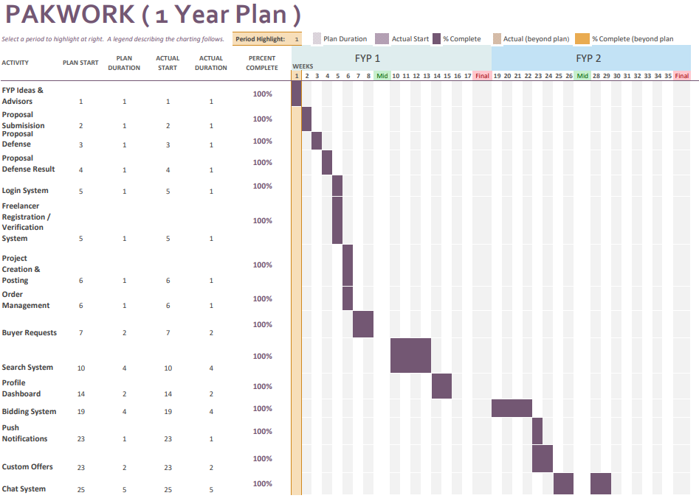

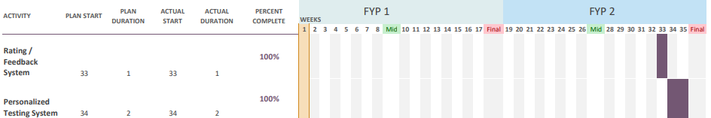

# 12. Work Breakdown Structure

**WBS & Gantt Chart (FYP 1) (Fall)**

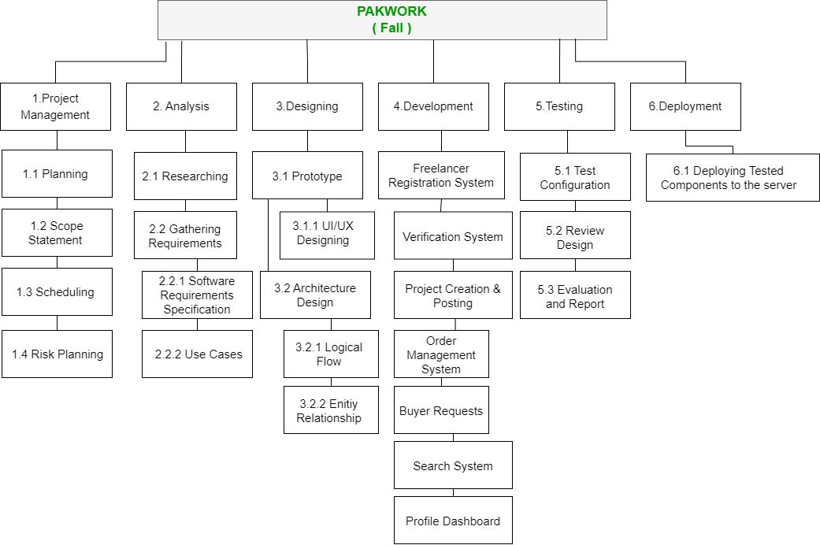

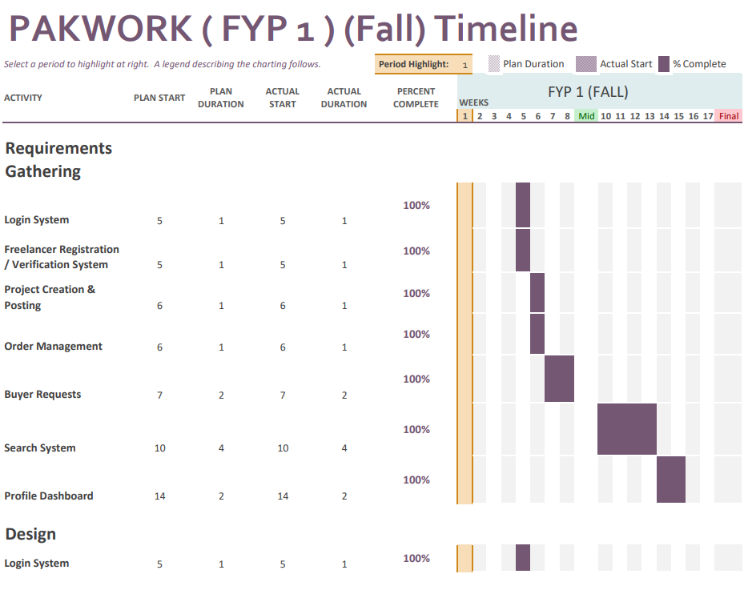

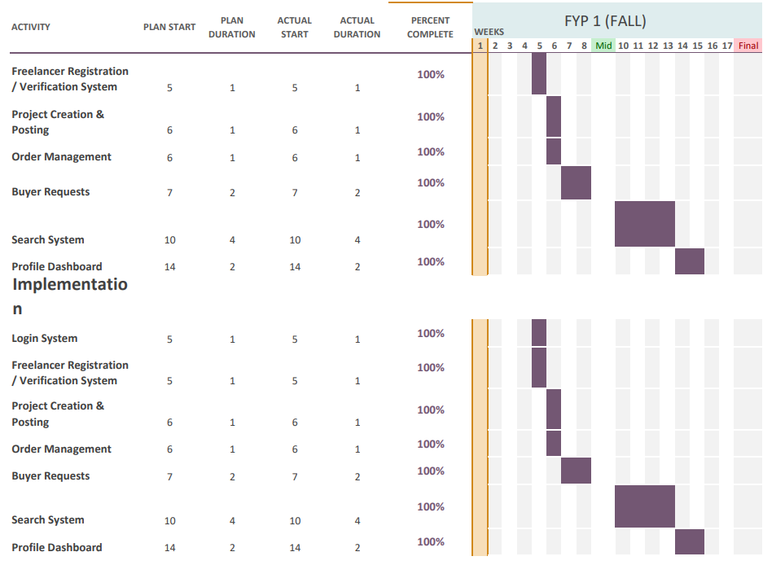

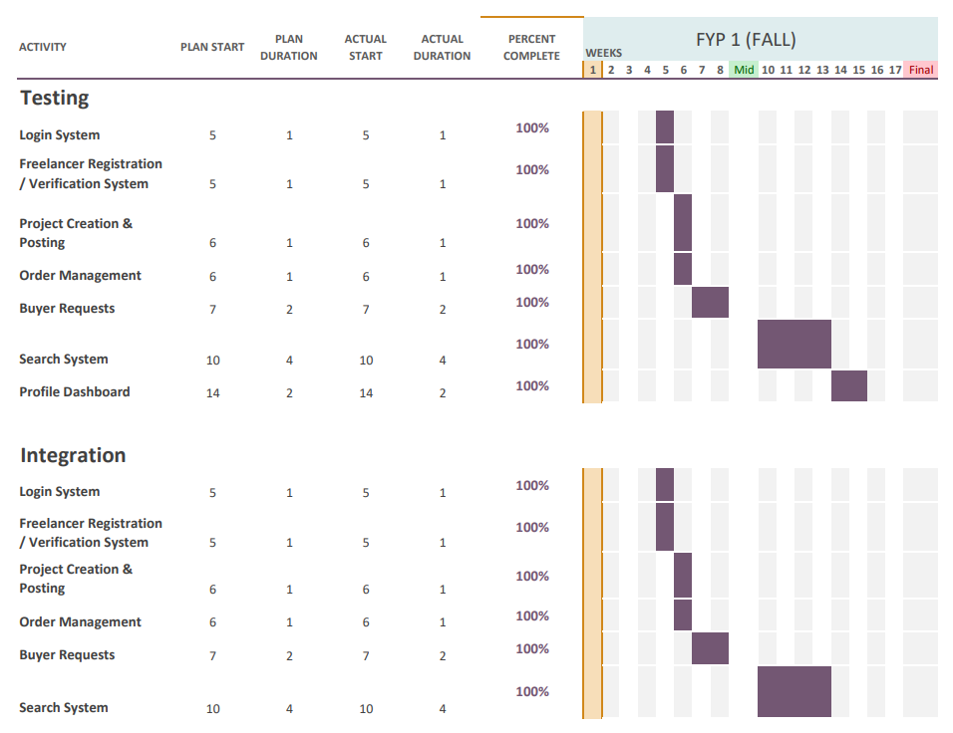

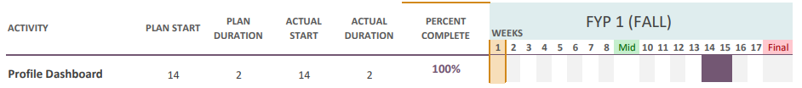

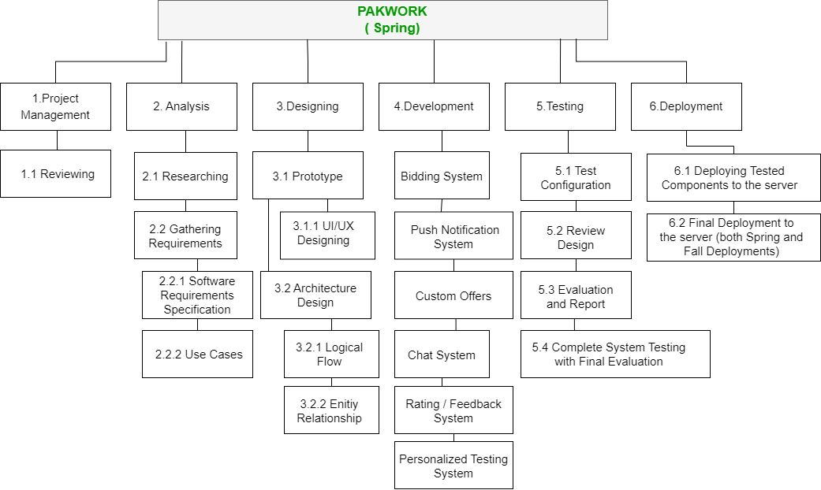**WBS & Gantt Chart (FYP 2) (Spring)**

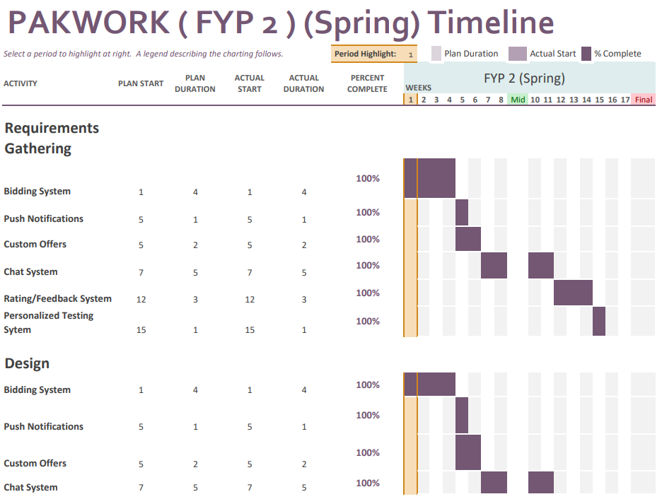

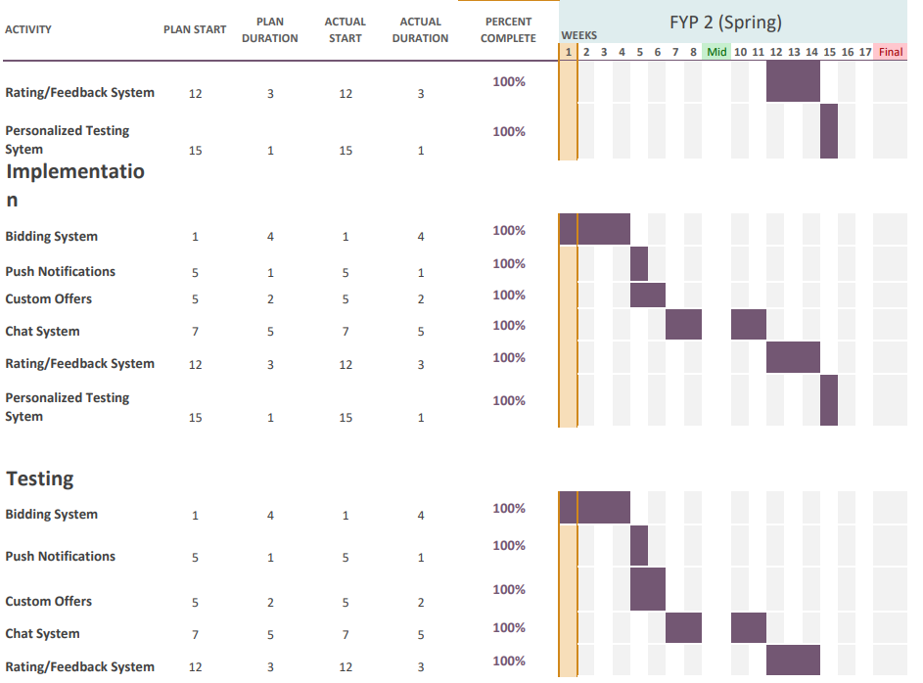

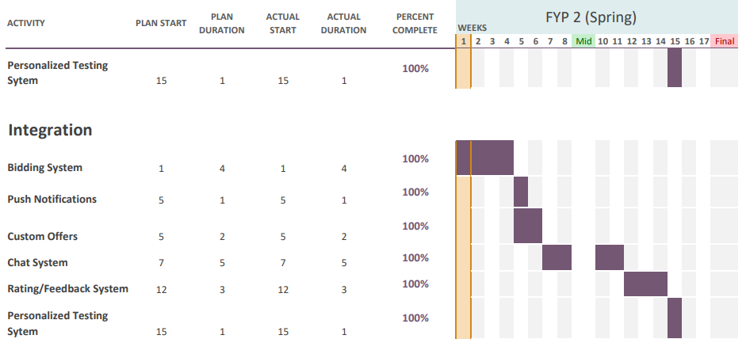

# 13. References

* Daniel Ruby “20+ Freelance Statistics Including All Facts & Data (2022)” DemandSage, August 13th 2022, <https://www.demandsage.com/freelance-statistics/>
* TechAbu “Top 10 Countries with The Most Freelancers 2022” TechAbu, June 12th 2022, <https://techabu.co/freelancing/top-10-countries-with-most-> freelancers

# Software Requirements Specification

# Introduction

## Purpose

A Freelancing platform for freelancers. Where freelancers can easily sell their gigs and offer services to potential clients/businesses. We aim to provide a fully featured platform that provides everything necessary for a seamless process of a transaction between two entities.

## Document Conventions

The format of this SRS is simple. Indentation is used on general topics and or specific points of interest with ‘Times font’ and are in a larger font size compared to the regular text. The headings have been Bold and the text size used is 14 and for the regular text the text size used is 12.

## Intended Audience and Reading Suggestions

This document is to be read by the intended for project manager and teachers. This document is particularly intended for users of the website for understanding the product.

## Product Scope

We aim to create a platform that targets freelancers with much easier policies and regional service charges. On the other hand, to tackle the issue of unprofessional and unskilled freelancers, we aim to provide a customized filtering process to ensure that only professional and skilled freelancers can be allowed to work on the platform. We also provide a customized test related to the job that is being bided by freelancers so that only matched freelancers can bid on outsourced projects by businesses, as this way we can tackle much of the filtering part we can offer to the clients. To tackle the issue of the order policy we will make sure that the freelancer has the choice to accept or decline customer job offers made by the client.

## References

- IEEE Template for System Requirement Specification Documents: <https://goo.gl/nsUFwy>

# Overall Description

## Product Perspective

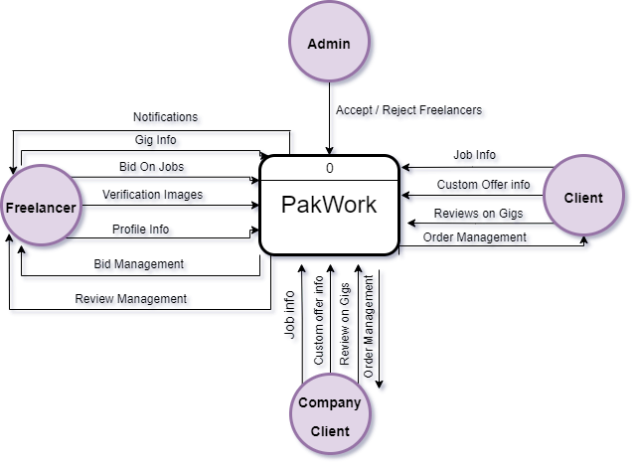

## Product Functions

* Freelancer Registration & Verification System
* Gig / Job Creation & Posting
* Order Management
* Buyer Requests
* Search System
* Profile Dashboard
* Bidding System
* Push Notification System
* Custom Offers
* Chat System
* Rating/Feedback System
* Personalized Testing System

## User Classes and Characteristics

There will be technically 4 types of users in the system

* **Freelancer**: The person that will be providing the services to the clients and the companies
* **Administrator**: The person responsible for verifying the freelancer’s identity
* **Client**: The person that will publish jobs and custom offers to freelancers to do tasks.
* **Company Client**: Company that will publish jobs and custom offers to freelancers to do tasks.

## Operating Environment

* **Software Preferences**: The website requires internet access to the internet and browsers such as Chrome, Firefox, MS Edge, Safari
* **Hardware Preferences**: Website can be accessed using PC/Laptop or Mobile/Tablet

## Design and Implementation Constraints

Some system design limitation constraints come from a payment holding system. Which is a common feature which is used by these platforms to cater claims/disputes. Since we are not implementing a payment gateway system or wallet system, hence we are also not implementing this feature.

## User Documentation

The website is self-explanatory for the user, that’s why no user manual is provided.

## Assumptions and Dependencies

* User must have an active internet connection to access the website
* User must enter valid details into the website
* Proper identification documents are provided to be verified to use the platform

# External Interface Requirements

## User Interfaces

**Main Page**

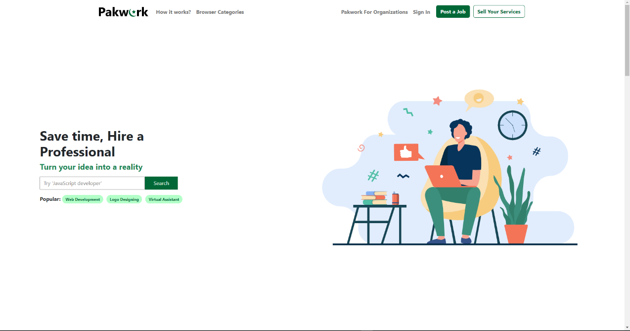

**Freelancer Registration**

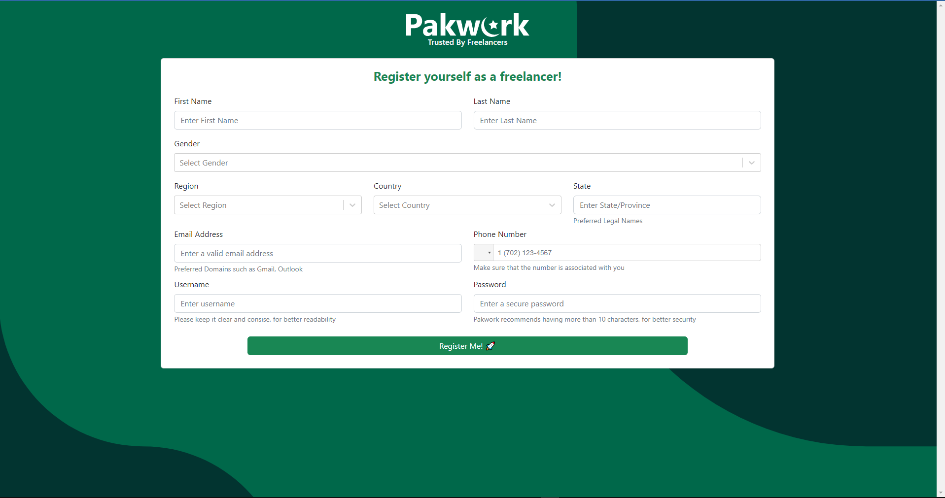

**Client Registration**

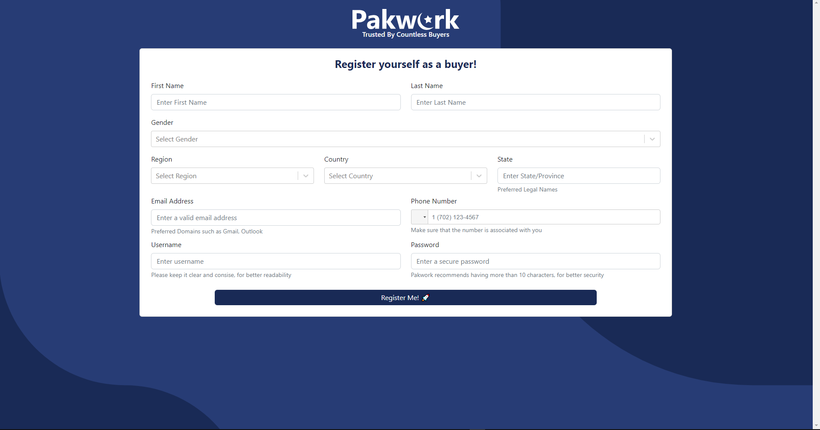

**Company Client Registration**

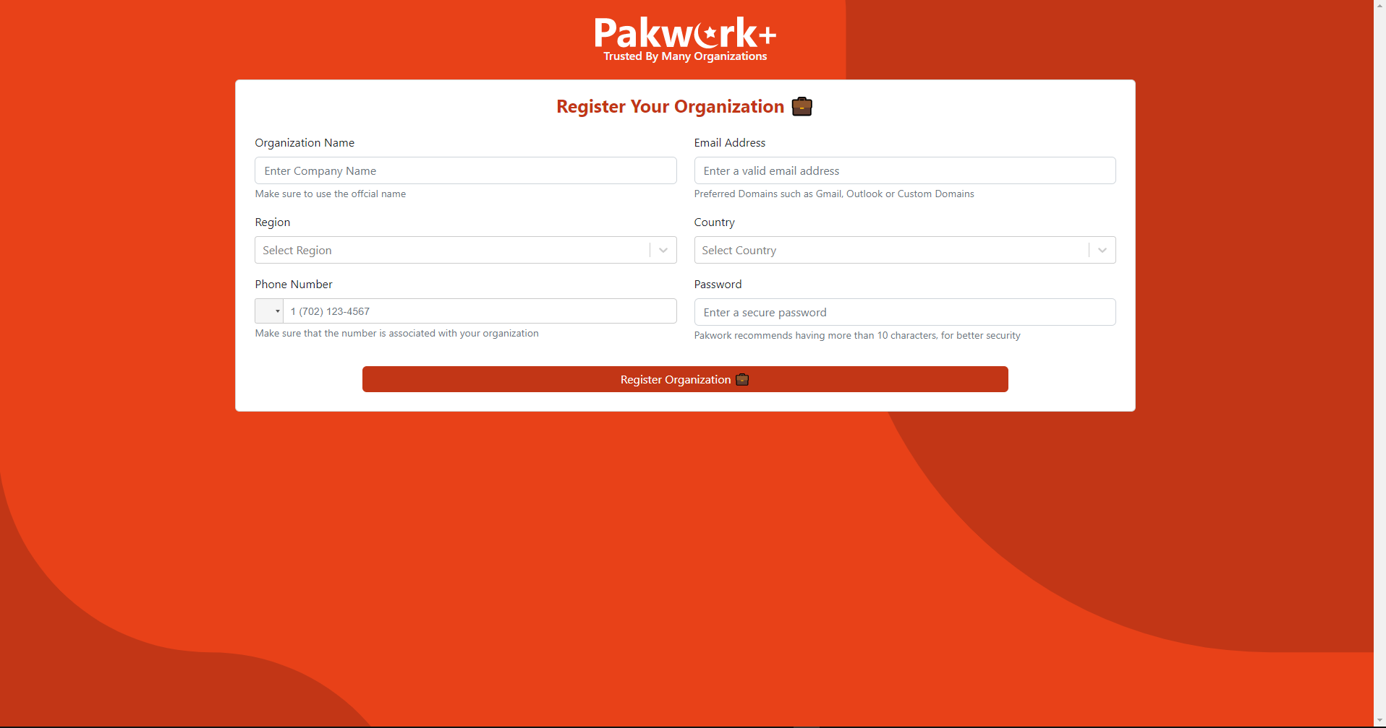

**Profile Dashboard**

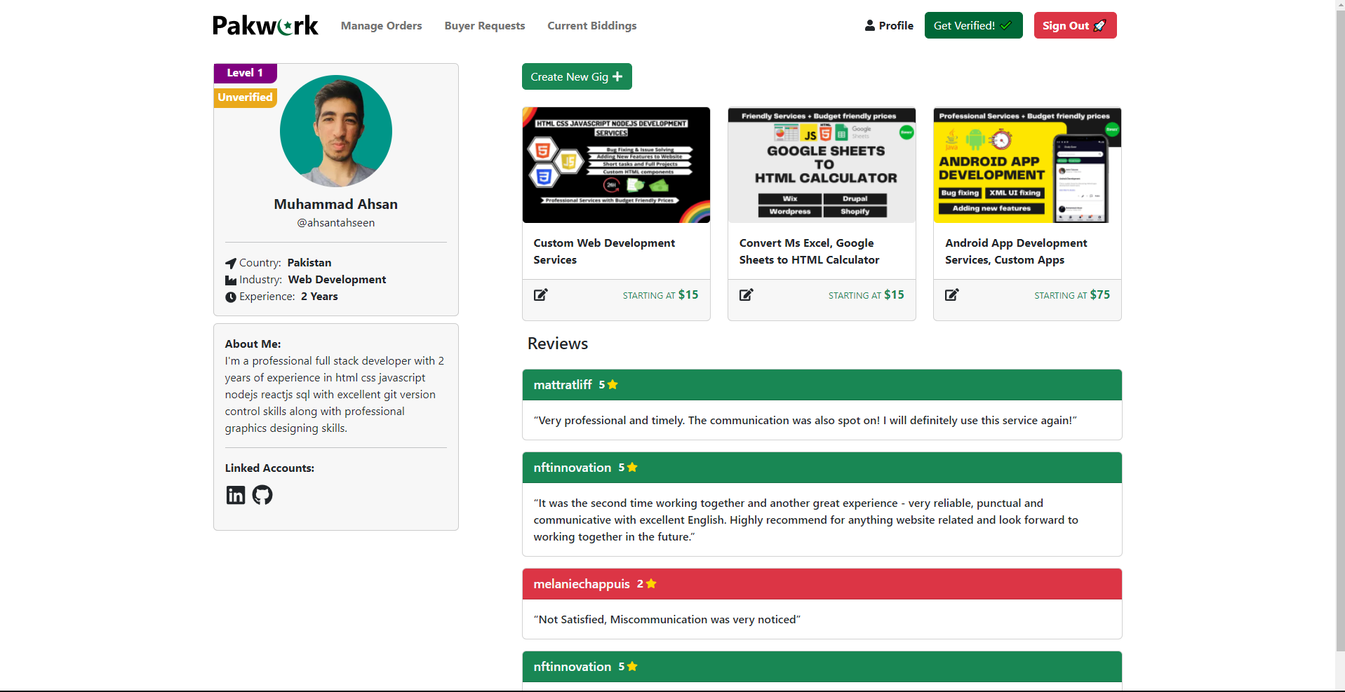

**Upload Verification Images**

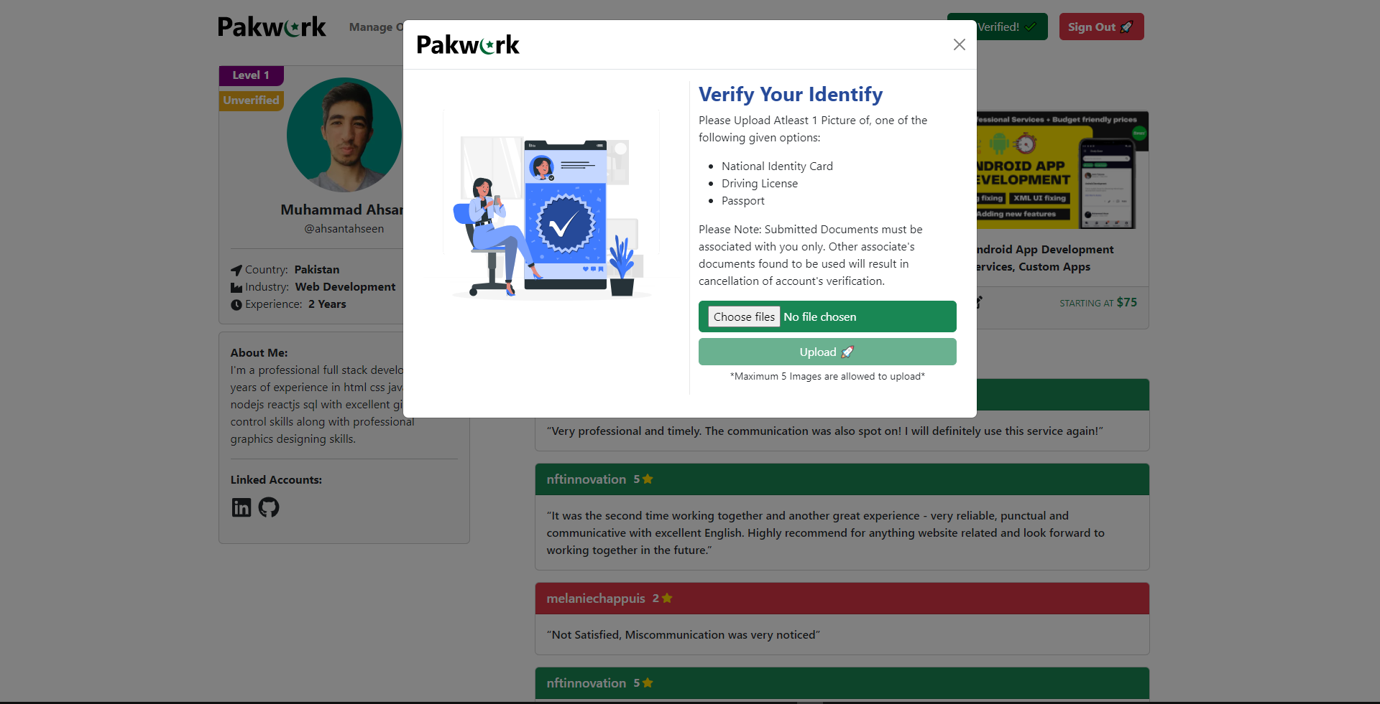

**Administrator Login**

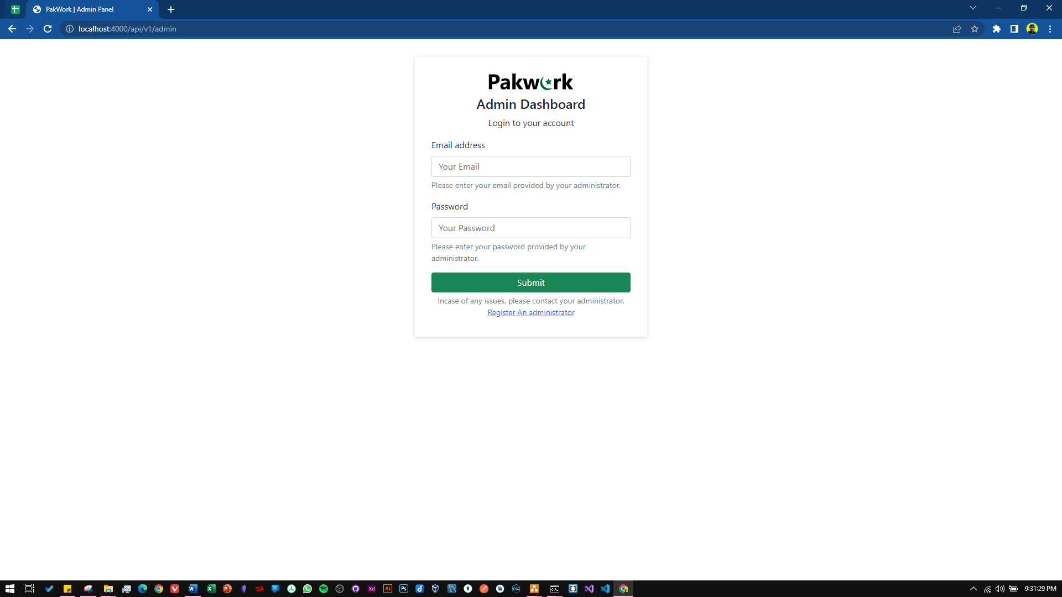

**Displaying Unverified Freelancers**

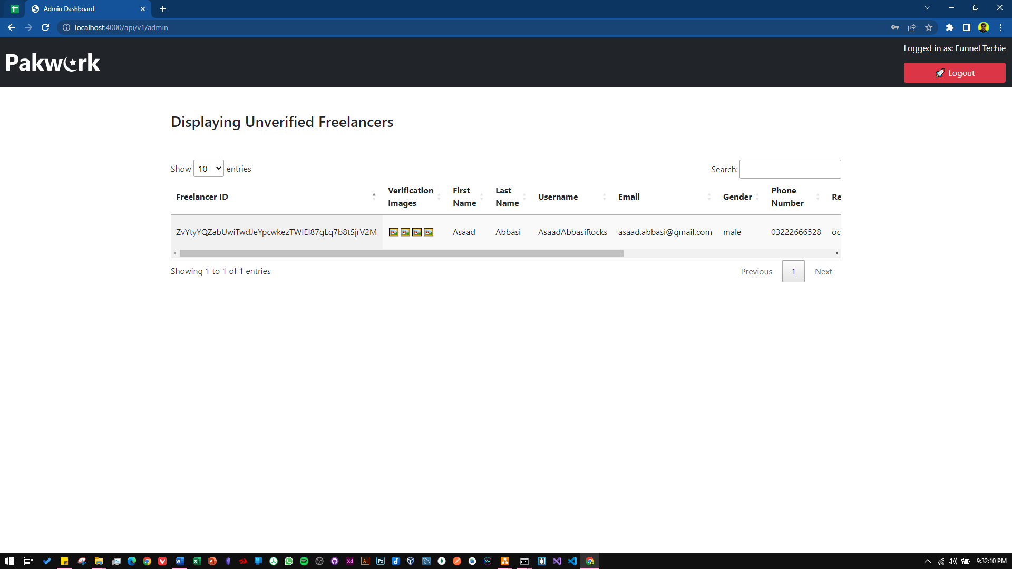

## Hardware Interfaces

No hardware interfaces are required since the software has no direct relation or dependability on an external hardware device. But a good fast internet connection is recommended for usage of the website

## Software Interfaces

* Visual Studio Code
* MySQL
* MongoDB
* Sockets IO

## Communications Interfaces

Communication interface used in this system is HTTP (Hyper Text Transfer Protocol) and WebSocket protocol with polling as a fallback option for chat messages.

# System Features

## Freelancer Registration / Verification System

### Description and Priority

This system is used to register and verify the freelancer before they can start posting gigs and bidding on jobs.

### Stimulus/Response Sequences

#### 

|  |  |  |  |  |  |
| --- | --- | --- | --- | --- | --- |
| **Use Case Name:** | | | Freelancer Registration / Verification System | | |
| **Summary:** | | | Register and verify freelancer before they use the platform | | |
| **User/Actor:** | | | Freelancer, Administrator | | |
| **Preconditions:** | | | * Internet connection necessary * Valid information for registering | | |
| **Basic Course of events/happy path** | | | | | |
| **Step** | | **User Actions** | | | **System Actions** |
| 1 | | Freelancers inputs all valid information in registration field | | | Wait for the registration button to click |
| 2 | | Registration button clicked | | | * System sends an email verification link to user’s email address * Saves data to database |
| 3 | | User Logs In & Uploads verification images | | | * Save verification images in database * Send’s pending request to administrator to foresee |
| Alternate Flow | | | | | |
| **Step** | **User Actions** | | | **System Actions** | |
| 1 | Wrong Username or password entered when logging in | | | Displays an error message “Invalid username or password” | |
| Post conditions | | | | | |
| * Verification request is accepted/rejected by the administrator after which freelancer can use the platform | | | | | |
| Author | | | | | |
| Asaad Noman | | | | | |

### Functional Requirements

|  |  |  |  |  |  |  |  |  |
| --- | --- | --- | --- | --- | --- | --- | --- | --- |
| **Test Case ID** | | PW_001 | **Test Case Description** | | Testing Freelancer Registration / Verification System | | | |
| **Created By** | | Asaad | **Reviewed By** | | Ahsan | | **Version** | | 1.9 |
|  |  |  |  |  |  |  |  |  |  |  |
| **QA Tester’s Log** | | N/A | | | |  |  |  |  |  |
|  |  |  |  |  |  |  |  |  |  |  |
| **Tester's Name** | | Asaad | **Date Tested** | | 9th November 2022 | | **Test Case (Pass/Fail/Not Executed)** | | Pass |
|  |  |  |  |  |  |  |  |  |  |  |
| **S #** | **Prerequisites:** | | |  | **S #** | **Test Data** | | |
| 1 | Access to Chrome Browser | | |  | 1 | email = [asaad@gmail.com](mailto:asaad@gmail.com) | | |
| 2 |  | | |  | 2 | Password = 1234567890 | | |
| 3 |  | | |  | 3 | First_name = Asaad | | |
| 4 |  | | |  | 4 | Last_name = Abbasi | | |
|  |  | | |  |  | Country = Pakistan | | |
|  |  | | |  |  | State = Karachi | | |
|  |  | | |  |  | Region = Asia | | |
|  |  | | |  |  | Phone_number = 03002119222 | | |
|  |  | | |  |  | Username= AsaadNA | | |
|  |  |  |  |  |  |  |  |  |  |  |
| **Test Scenario** | Verify on entering the credentials the freelancer account is created and an email verification link is sent | | | | | |  |  |  |  |
|  |  |  |  |  |  |  |  |  |  |  |
| **Step #** | **Step Details** | | **Expected Results** | | **Actual Results** | | | **Pass / Fail / Not executed / Suspended** |
|
| 1 | Navigate to http://localhost:3000/ | | Site should open | | As Expected | | | Pass |
| 2 | Click “Sell your services” | | Credential can be entered | | As Expected | | | Pass |
| 3 | Click Register | | Freelancer registered | | As Expected | | | Pass |
| 4 | Email verification link sent | | Link sent | | As Expected | | | Pass |

## Gig / Job Creating & Posting

### Description & Priority

This feature is used by the freelancer, client & the company client to post gigs, jobs, custom offers respectively

### Stimulus/Response Sequences

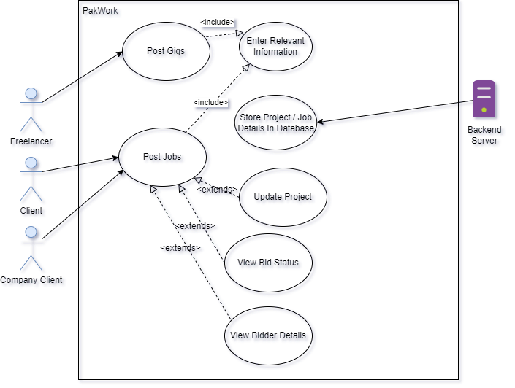

|  |  |  |  |  |  |
| --- | --- | --- | --- | --- | --- |
| **Use Case Name:** | | | Gig/Job Creation & Posting | | |
| **Summary:** | | | Feature used by freelancers, client & company clients to post job, gigs & send custom offers | | |
| **User/Actor:** | | | Freelancer, Client, Company Client | | |
| **Preconditions:** | | | The users of the system must be logged in. | | |
| **Basic Course of events/happy path** | | | | | |
| **Step** | | **User Actions** | | | **System Actions** |
| 1 | | The User clicks the create gig/job button | | | System displays a modal dialog for user to enter the necessary details |
| 2 | | User Clicks Post Button | | | * Job/Gig gets saved in the database * Displayed on the profile dashboard |
| Alternate Flow | | | | | |
| **Step** | **User Actions** | | | **System Actions** | |
| 1 | Some Details are left out and post button is clicked | | | Displays an error message to fill the empty fields | |
| Post conditions | | | | | |
| The website is refreshed and updated information is displayed on the dashboard | | | | | |
| Author | | | | | |
| Asaad Noman | | | | | |

### Functional Requirements

|  |  |  |  |  |  |  |  |  |
| --- | --- | --- | --- | --- | --- | --- | --- | --- |
| **Test Case ID** | | PW_002 | **Test Case Description** | | Testing Gig/Job Posting | | | |
| **Created By** | | Asaad | **Reviewed By** | | Ahsan | | **Version** | | 1.0 |
|  |  |  |  |  |  |  |  |  |  |  |
| **QA Tester’s Log** | | Testing this from the freelancer side | | | |  |  |  |  |  |
|  |  |  |  |  |  |  |  |  |  |  |
| **Tester's Name** | | Asaad | **Date Tested** | | 9th November 2022 | | **Test Case (Pass/Fail/Not Executed)** | | Pass |
|  |  |  |  |  |  |  |  |  |  |  |
| **S #** | **Prerequisites:** | | |  | **S #** | **Test Data** | | |
| 1 | Should be logged in | | |  | 1 | title = Sell Scripts for automation | | |
| 2 | Should be verified & activated | | |  | 2 | startingPrice= 10 | | |
| 3 |  | | |  | 3 | detail = lorem ipsum | | |
|  |  |  |  |  |  |  |  |  |  |  |
| **Test Scenario** | Verify on posting that the gig is posted properly and is displaying | | | | | |  |  |  |  |
|  |  |  |  |  |  |  |  |  |  |  |
| **Step #** | **Step Details** | | **Expected Results** | | **Actual Results** | | | **Pass / Fail / Not executed / Suspended** |
|
| 1 | Navigate to http://localhost:3000/profile/ | | Site should open | | As Expected | | | Pass |
| 2 | Click create Gig button | | Credential can be entered | | As Expected | | | Pass |
| 3 | Click Post | | Gig has been posted | | As Expected | | | Pass |

## Profile Dashboard

### Description & Priority

This feature is basically a dashboard for the user whether it be client. Company client or freelancer. They can view, create their jobs/gigs, change profile picture or update their bio or upload verification images.

### Stimulus/Response Sequences

|  |  |  |  |  |  |
| --- | --- | --- | --- | --- | --- |
| **Use Case Name:** | | | Profile Dashboard | | |
| **Summary:** | | | A Feature that allows the users to see and update their profile bio, upload profile pictures, verification images and their gig and jobs posted | | |
| **User/Actor:** | | | Freelancer, Client, Company Client | | |
| **Preconditions:** | | | The users of the system must be logged in. | | |
| **Basic Course of events/happy path** | | | | | |
| **Step** | | **User Actions** | | | **System Actions** |
| 1 | | The user clicks on profile dashboard | | | If profile not completed system tells to complete profile information |
| 2 | | User completes profile info | | | System allows user to view all the necessary information on the profile dashboard |
| Alternate Flow | | | | | |
| **Step** | **User Actions** | | | **System Actions** | |
| 1 | User tries to view profile without completing profile info | | | System continues to show error to complete profile information. | |
| Post conditions | | | | | |
| Every information is available in the profile dashboard for the user to see. | | | | | |
| Author | | | | | |
| Asaad Noman | | | | | |

### Functional Requirements

|  |  |  |  |  |  |  |  |  |
| --- | --- | --- | --- | --- | --- | --- | --- | --- |
| **Test Case ID** | | PW_003 | **Test Case Description** | | Testing the profile dashboard | | | |
| **Created By** | | Asaad | **Reviewed By** | | Ahsan | | **Version** | | 1.0 |
|  |  |  |  |  |  |  |  |  |  |  |
| **QA Tester’s Log** | | Reviewing the freelancer profile | | | |  |  |  |  |  |
|  |  |  |  |  |  |  |  |  |  |  |
| **Tester's Name** | | Asaad | **Date Tested** | | 9th November 2022 | | **Test Case (Pass/Fail/Not Executed)** | | Pass |
|  |  |  |  |  |  |  |  |  |  |  |
| **S #** | **Prerequisites:** | | |  | **S #** | **Test Data** | | |
| 1 | Should be loggedin | | |  | 1 | N/A | | |
|  |  |  |  |  |  |  |  |  |  |  |
| **Test Scenario** | Verify if all the data on profile dashboard is displaying correctly | | | | | |  |  |  |  |
|  |  |  |  |  |  |  |  |  |  |  |
| **Step #** | **Step Details** | | **Expected Results** | | **Actual Results** | | | **Pass / Fail / Not executed / Suspended** |
|
| 1 | Navigate to <http://localhost:3000/profile> | | Site should open | | As Expected | | | Pass |
| 2 | Profile is displayed | | All Information is being displayed | | As Expected | | | Pass |

## Search System

### Description & Priority

This feature will allow the clients and freelancer respectively to search for gigs / jobs on the platform

### Stimulus/Response Sequences

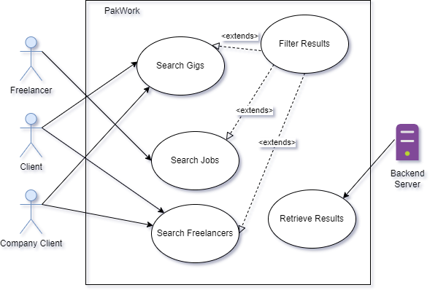

|  |  |  |  |  |  |
| --- | --- | --- | --- | --- | --- |
| **Use Case Name:** | | | Search System | | |
| **Summary:** | | | This feature allows any type of users to search for desired data in the platform | | |
| **User/Actor:** | | | Freelancer, Client, Company Client | | |
| **Preconditions:** | | | Working internet connection | | |
| **Basic Course of events/happy path** | | | | | |
| **Step** | | **User Actions** | | | **System Actions** |
| 1 | | The user clicks on search box | | | Does nothing |
| 2 | | User selects type of information needed to search from combo box | | | Does nothing |
| 3 | | User enters desired text | | | System starts giving suggestion based on the input given |
| 4 | | User presses enter | | | A new page is loaded giving the matched result to the user query |
| Alternate Flow | | | | | |
| **Step** | **User Actions** | | | **System Actions** | |
| 1 | User writes in search box | | | Result is not retrieved, since no matched query from the database. Data does not exist | |
| Post conditions | | | | | |
| Search result is displayed | | | | | |
| Author | | | | | |
| Asaad Noman | | | | | |

### Functional Requirements

|  |  |  |  |  |  |  |  |  |
| --- | --- | --- | --- | --- | --- | --- | --- | --- |
| **Test Case ID** | | PW_004 | **Test Case Description** | | Testing the search system | | | |
| **Created By** | | Asaad | **Reviewed By** | | Ahsan | | **Version** | | 1.0 |
|  |  |  |  |  |  |  |  |  |  |  |
| **QA Tester’s Log** | | N/A | | | |  |  |  |  |  |
|  |  |  |  |  |  |  |  |  |  |  |
| **Tester's Name** | | Asaad | **Date Tested** | | 9th November 2022 | | **Test Case (Pass/Fail/Not Executed)** | | Pass |
|  |  |  |  |  |  |  |  |  |  |  |
| **S #** | **Prerequisites:** | | |  | **S #** | **Test Data** | | |
| 1 | Internet Connectivity | | |  | 1 | Search box: Web Development | | |
|  |  |  |  |  |  |  |  |  |  |  |
| **Test Scenario** | Verify if all the data on profile dashboard is displaying correctly | | | | | |  |  |  |  |
|  |  |  |  |  |  |  |  |  |  |  |
| **Step #** | **Step Details** | | **Expected Results** | | **Actual Results** | | | **Pass / Fail / Not executed / Suspended** |
|
| 1 | Navigate to [http://localhost:3000/](http://localhost:3000/profile) | | Site should open | | As Expected | | | Pass |
| 2 | Click on search box and select type of information needed and start typing | | Information displayed dynamically | | As Expected | | | Pass |
| 3 | Press enter | | New page loaded and information displayed | | As Expected | | | Pass |

## Buyer Requests

### Description & Priority

This is basically a job board dashboard that allows miscellaneous jobs to be posted that do not fit into the categories offered in the platform.

### Stimulus/Response Sequences

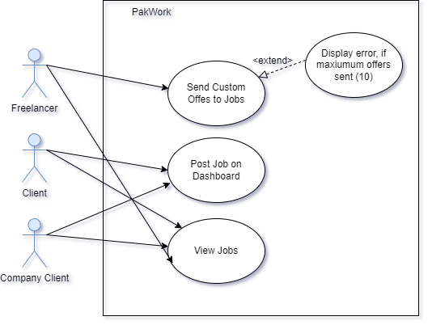

|  |  |  |  |  |  |
| --- | --- | --- | --- | --- | --- |
| **Use Case Name:** | | | Buyer Requests | | |
| **Summary:** | | | This is a job board dashboard for miscellaneous jobs. | | |
| **User/Actor:** | | | Freelancer, Client, Company Client | | |
| **Preconditions:** | | | Should be logged in | | |
| **Basic Course of events/happy path** | | | | | |
| **Step** | | **User Actions** | | | **System Actions** |
| 1 | | The user clicks on buyer request dashboard | | | Displays all the current jobs posted and Create job button depending on the user |
| 2 | | If user is a client/company client, they click create job button | | | Modal Dialog is showed |
| 3 | | User enters desired information about the job | | | System waits for the post button to be clicked |
| 4 | | User clicks the post button | | | New Job has been posted |
| Alternate Flow | | | | | |
| **Step** | **User Actions** | | | **System Actions** | |
| 1 | If user is a freelancer, inputs the bid | | | Does nothing | |
| 2 | User clicks the bid now button | | | New Bid has been placed and the bid is updated on the screen | |
| Author | | | | | |
| Asaad Noman | | | | | |

## Order Management

### Description & Priority

This is an order management feature where freelancers, clients and company clients can manage their orders respectively.

### Stimulus/Response Sequences

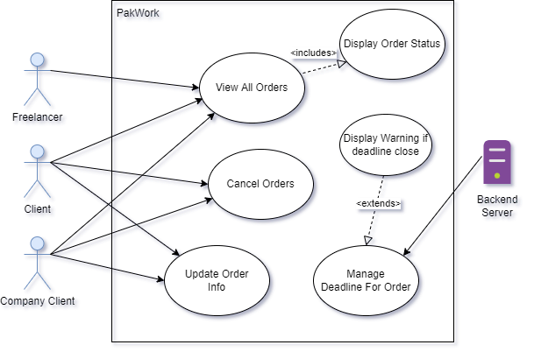

|  |  |  |  |
| --- | --- | --- | --- |
| **Use Case Name:** | | Order Management | |
| **Summary:** | | This is an order management dashboard to manage the orders for freelancers, clients and company clients | |
| **User/Actor:** | | Freelancer, Client, Company Client | |
| **Preconditions:** | | * Should be logged in * Some order should be in progress | |
| **Basic Course of events/happy path** | | | |
| **Step** | **User Actions** | | **System Actions** |
| 1 | The user clicks on order management dashboard | | System displays all the orders in a list |
| Author | | | |
| Asaad Noman | | | |

## Custom Offers

### Description & Priority

This is a feature only for clients and company clients, to send custom offers to their desired/scouted freelancers.

### Stimulus/Response Sequences

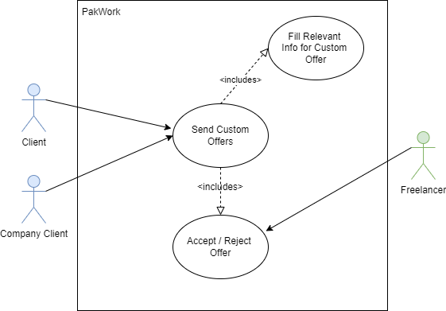

|  |  |  |  |
| --- | --- | --- | --- |
| **Use Case Name:** | | Custom Offers | |
| **Summary:** | | This feature allows clients and company clients to send custom offers to freelancers of their choice. | |
| **User/Actor:** | | Freelancer, Client, Company Client | |
| **Preconditions:** | | The users of the system must be logged in. | |
| **Basic Course of events/happy path** | | | |
| **Step** | **User Actions** | | **System Actions** |
| 1 | The user clicks on profile of freelancer | | System displays all information of the freelancers on a new page |
| 2 | User clicks custom offer buttons | | System shows a modal dialog for inputting information |
| 3 | User fills all info and clicks the send offer button | | Offer is sent to the freelancer and is awaiting response |
| Post conditions | | | |
| The offer status is pending until freelancer sees it and accepts or rejects the custom offer | | | |
| Author | | | |
| Asaad Noman | | | |

## Bidding System

### Description & Priority

This is a bidding system for jobs, freelancers can bid on jobs and compete with other freelancers to quote the best price for a project.

### Stimulus/Response Sequences

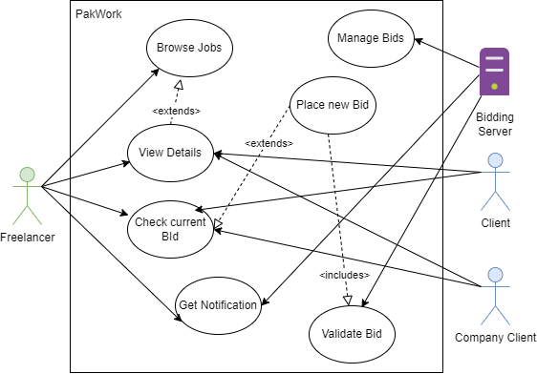

|  |  |  |  |  |  |
| --- | --- | --- | --- | --- | --- |
| **Use Case Name:** | | | Bidding System | | |
| **Summary:** | | | This is a bidding system for jobs, freelancers can bid on jobs and compete with other freelancers to quote the best price for a project. | | |
| **User/Actor:** | | | Freelancer, Client, Company Client | | |
| **Preconditions:** | | | Should be logged in | | |
| **Basic Course of events/happy path** | | | | | |
| **Step** | | **User Actions** | | | **System Actions** |
| 1 | | Freelancer views all the jobs listed | | | Does Nothing |
| 2 | | Freelancer clicks detail button on the job posting | | | System shows all the relevant description and files related to the job posted |
| 3 | | Freelancer enters bid and clicks the bid now button | | | System validates the bid, if all correct, bid is placed |
| Alternate Flow | | | | | |
| **Step** | **User Actions** | | | **System Actions** | |
| 1 | If user is a freelancer, inputs an invalid bid | | | Displays an error message | |
| Author | | | | | |
| Asaad Noman | | | | | |

## Push Notification System

### Description & Priority

This notification system is used to notify user, if they have been outbidded or not, if they received a new chat message or custom offer.

### Stimulus/Response Sequences

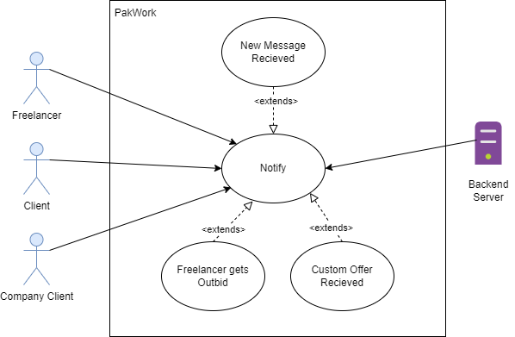

|  |  |  |  |
| --- | --- | --- | --- |
| **Use Case Name:** | | Push Notification System | |
| **Summary:** | | This system allows the users to get notified when certain actions take place such as new message, outbid on jobs, custom offers | |
| **User/Actor:** | | Freelancer, Client, Company Client | |
| **Preconditions:** | | The users of the system must be logged in. | |
| **Basic Course of events/happy path** | | | |
| **Step** | **User Actions** | | **System Actions** |
| 1 | The user gets outbid on project | | Sends a notification to the user, intimating of the outbid |
| Author | | | |
| Asaad Noman | | | |

## Chat System

### Description & Priority

A Feature that can be used by the freelancer & clients respectively to communication with each other without leaving the platform.

### Stimulus/Response Sequences

|  |  |  |  |
| --- | --- | --- | --- |
| **Use Case Name:** | | Chat System | |
| **Summary:** | | A Feature that can be used by the freelancer & clients respectively to communication with each other without leaving the platform. | |
| **User/Actor:** | | Freelancer, Client, Company Client | |
| **Preconditions:** | | Should be logged in | |
| **Basic Course of events/happy path** | | | |
| **Step** | **User Actions** | | **System Actions** |
| 1 | Opens Chat Dashboard | | Displays All User list with the user has chat with |
| 2 | Selects A User from list | | Retrieves chat history from database and opens up a chat box with a socket connection |
| 3 | User sends message | | Using sockets message is sent and message is stored in the database |
| Author | | | |
| Asaad Noman | | | |

## Rating/Feedback System

### Description & Priority

This rating and feedback system is a feature for clients and company clients to leave a review of the work/performance of the freelancer on the job. This helps other user to differentiate between good and bad freelancers. Also helps the search system.

### Stimulus/Response Sequences

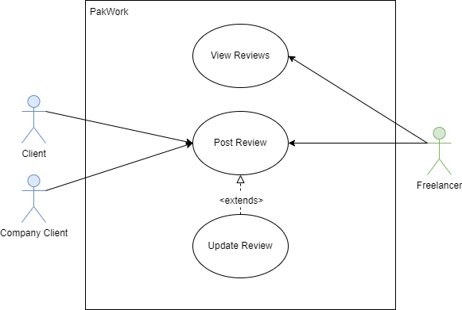

|  |  |  |  |  |  |
| --- | --- | --- | --- | --- | --- |
| **Use Case Name:** | | | Rating/Feedback System | | |
| **Summary:** | | | This rating and feedback system is a feature for clients and company clients to leave a review of the work/performance of the freelancer on the job. This helps other user to differentiate between good and bad freelancers. Also helps the search system. | | |
| **User/Actor:** | | | Freelancer, Client, Company Client | | |
| **Preconditions:** | | | * Should be logged in * Must be a verified buyer of the services of the freelancer | | |
| **Basic Course of events/happy path** | | | | | |
| **Step** | | **User Actions** | | | **System Actions** |
| 1 | | Click the post a review button | | | Open up a modal dialog |
| 2 | | User enters the details of the review, rating etc. | | | Does nothing |
| 3 | | Clicks the submit button | | | System saves the review in the database and refreshes |
| Alternate Flow | | | | | |
| **Step** | **User Actions** | | | **System Actions** | |
| 1 | User tries to submit without filling all information | | | Displays an error message | |
| Author | | | | | |
| Asaad Noman | | | | | |

## Personalized Testing System

### Description & Priority

This feature is available only to the Company client. This allows to set a test before project bidding for freelancer to filter the good ones from the bad ones. Also allows to create a customized test.

### Stimulus/Response Sequences

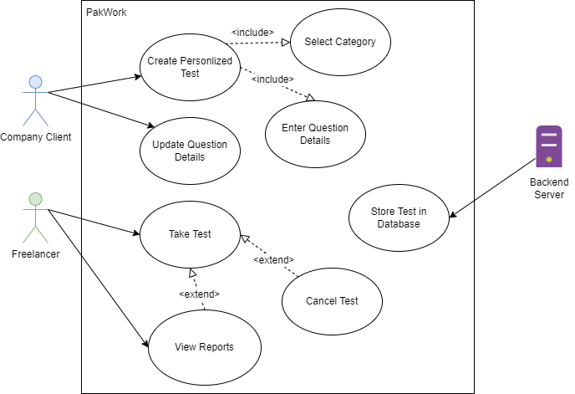

|  |  |  |  |
| --- | --- | --- | --- |
| **Use Case Name:** | | Personalized Testing System | |
| **Summary:** | | This feature is available only to the Company client. This allows to set a test before project bidding for freelancer to filter the good ones from the bad ones. Also allows to create a customized test. | |
| **User/Actor:** | | Freelancer, Company Client | |
| **Preconditions:** | | * Should be logged in * Must be logged in as a company client | |
| **Basic Course of events/happy path** | | | |
| **Step** | **User Actions** | | **System Actions** |
| 1 | Click the create test button | | Open up a modal dialog |
| 2 | User enters the details of the test and adds questions | | Does nothing |
| 3 | Clicks the submit button | | Saves the question in the database |
| 4 | Sets the test when posting new job | | System will ask freelancer to first take the test |
| Author | | | |
| Asaad Noman | | | |

# Other Nonfunctional Requirements

## Performance Requirements

N/A

## Safety Requirements

Do not deal with clients outside platform, for avoidance of being scammed.

## Security Requirements

Freelancer verification should be done thoroughly to avoid the problem of impersonation and multiple profiles of the same person on the platform to maintain the integrity of the system. All information must be placed securely to avoid data loss and invasion of privacy.

## Software Quality Attributes

* **Correctness**: The website should work as expected and contain minimal error and also should be bug free. It is achieved by systematically testing the system and its different components.
* **Maintainability**: System design of the website is done in such a way that it would be easy for the developer to maintain and fix the problems in the future.
* **Usability**: The use interface of the website is designed in such a way that it is easy to navigate and all features are self-explanatory.
* **Reliability**: The website provides secure and integrated communication system that connects freelancers to their clients with ease without making the need to leave the platform.
* **Testability**: This is a necessary attribute for SQA. This is thoroughly done as stated in the testing documents.

## Business Rules

N/A

# Other Requirements

N/A

Appendix A: Glossary

|  |  |  |
| --- | --- | --- |
| S.no | Terms | Description |
| 1 | User Interface | The means by which computer system interact with the user |
| 2 | Database | A structured set of data held in a computer |
| 3 | Sockets | A socket is a software architecture within a network node of a computer network that serves as an endpoint for receiving and sending data across a network |
| 4 | HTTP | Hypertext transfer protocol is a communication interface |

Appendix B: Analysis Models

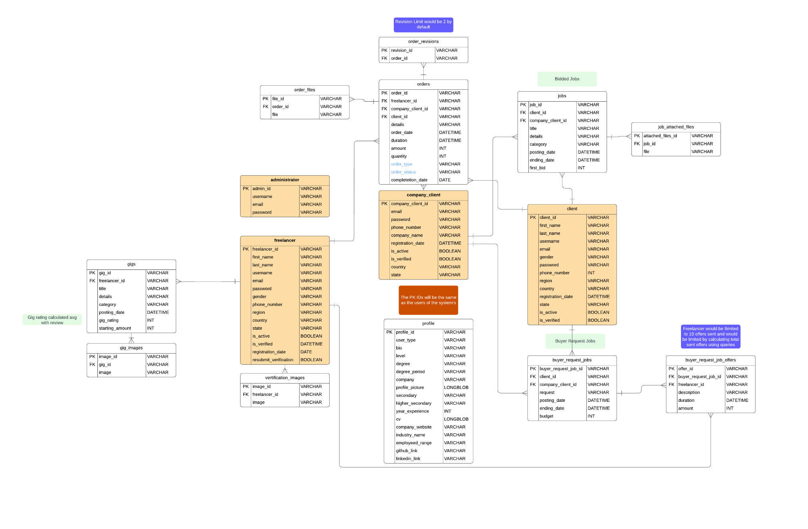ERD:

System Use Case Diagram:

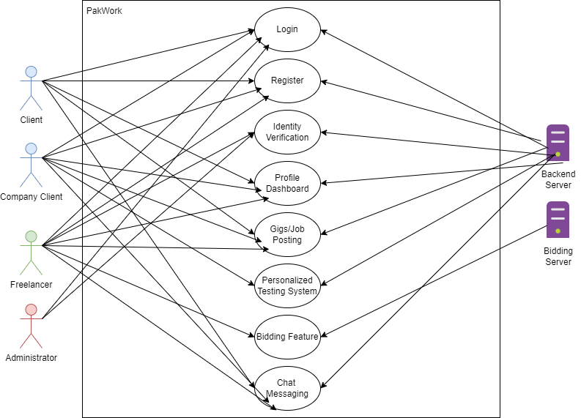

Domain Model:

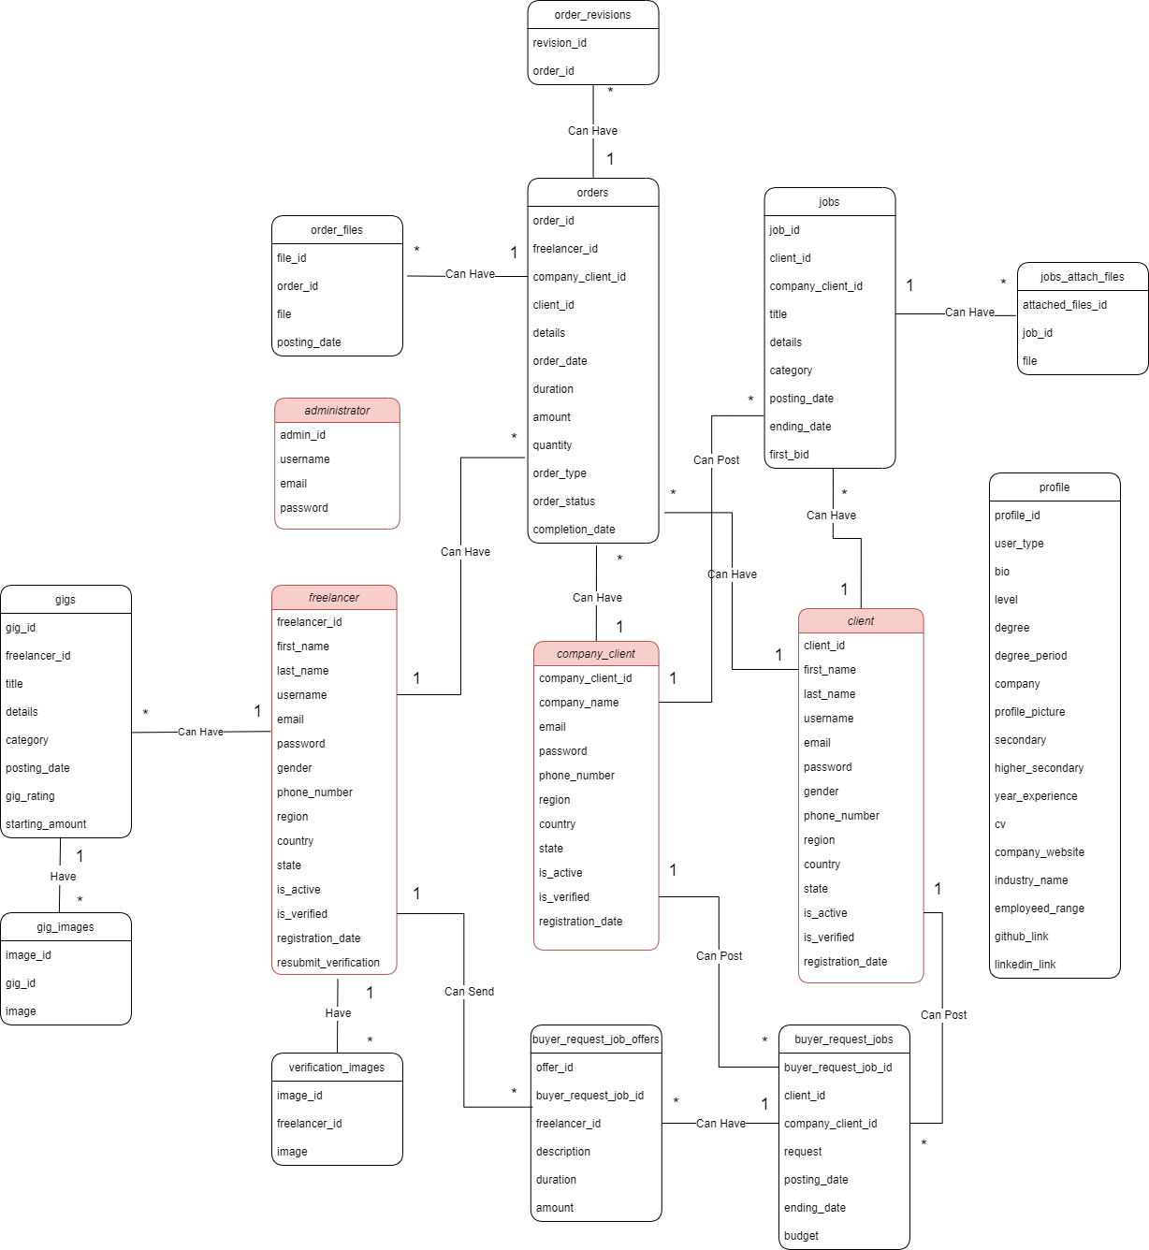

Appendix C: To Be Determined List

N/A

# Testing Documents

**1. Freelancer Registration/Verification System**

|  |  |  |  |  |  |  |  |  |
| --- | --- | --- | --- | --- | --- | --- | --- | --- |
| **Test Case ID** | | PW_001 | **Test Case Description** | | Testing Freelancer Registration / Verification System | | | |
| **Created By** | | Asaad | **Reviewed By** | | Ahsan | | **Version** | | 1.9 |
|  |  |  |  |  |  |  |  |  |  |  |
| **QA Tester’s Log** | | N/A | | | |  |  |  |  |  |
|  |  |  |  |  |  |  |  |  |  |  |
| **Tester's Name** | | Asaad | **Date Tested** | | 9th November 2022 | | **Test Case (Pass/Fail/Not Executed)** | | Pass |
|  |  |  |  |  |  |  |  |  |  |  |
| **S #** | **Prerequisites:** | | |  | **S #** | **Test Data** | | |
| 1 | Access to Chrome Browser | | |  | 1 | email = [asaad@gmail.com](mailto:asaad@gmail.com) | | |
| 2 |  | | |  | 2 | Password = 1234567890 | | |
| 3 |  | | |  | 3 | First_name = Asaad | | |
| 4 |  | | |  | 4 | Last_name = Abbasi | | |
|  |  | | |  |  | Country = Pakistan | | |
|  |  | | |  |  | State = Karachi | | |
|  |  | | |  |  | Region = Asia | | |
|  |  | | |  |  | Phone_number = 03002119222 | | |
|  |  | | |  |  | Username= AsaadNA | | |
|  |  |  |  |  |  |  |  |  |  |  |
| **Test Scenario** | Verify on entering the credentials the freelancer account is created and an email verification link is sent | | | | | |  |  |  |  |
|  |  |  |  |  |  |  |  |  |  |  |
| **Step #** | **Step Details** | | **Expected Results** | | **Actual Results** | | | **Pass / Fail / Not executed / Suspended** |
|
| 1 | Navigate to http://localhost:3000/ | | Site should open | | As Expected | | | Pass |
| 2 | Click “Sell your services” | | Credential can be entered | | As Expected | | | Pass |
| 3 | Click Register | | Freelancer registered | | As Expected | | | Pass |
| 4 | Email verification link sent | | Link sent | | As Expected | | | Pass |

**2. Gig/Job Posting**

|  |  |  |  |  |  |  |  |  |
| --- | --- | --- | --- | --- | --- | --- | --- | --- |
| **Test Case ID** | | PW_002 | **Test Case Description** | | Testing Gig/Job Posting | | | |
| **Created By** | | Asaad | **Reviewed By** | | Ahsan | | **Version** | | 1.0 |
|  |  |  |  |  |  |  |  |  |  |  |
| **QA Tester’s Log** | | Testing this from the freelancer side | | | |  |  |  |  |  |
|  |  |  |  |  |  |  |  |  |  |  |
| **Tester's Name** | | Asaad | **Date Tested** | | 9th November 2022 | | **Test Case (Pass/Fail/Not Executed)** | | Pass |
|  |  |  |  |  |  |  |  |  |  |  |
| **S #** | **Prerequisites:** | | |  | **S #** | **Test Data** | | |
| 1 | Should be logged in | | |  | 1 | title = Sell Scripts for automation | | |
| 2 | Should be verified & activated | | |  | 2 | startingPrice= 10 | | |
| 3 |  | | |  | 3 | detail = lorem ipsum | | |
|  |  |  |  |  |  |  |  |  |  |  |
| **Test Scenario** | Verify on posting that the gig is posted properly and is displaying | | | | | |  |  |  |  |
|  |  |  |  |  |  |  |  |  |  |  |
| **Step #** | **Step Details** | | **Expected Results** | | **Actual Results** | | | **Pass / Fail / Not executed / Suspended** |
|
| 1 | Navigate to http://localhost:3000/profile/ | | Site should open | | As Expected | | | Pass |
| 2 | Click create Gig button | | Credential can be entered | | As Expected | | | Pass |
| 3 | Click Post | | Gig has been posted | | As Expected | | | Pass |

**3. Profile Dashboard**

|  |  |  |  |  |  |  |  |  |
| --- | --- | --- | --- | --- | --- | --- | --- | --- |
| **Test Case ID** | | PW_003 | **Test Case Description** | | Testing the profile dashboard | | | |
| **Created By** | | Asaad | **Reviewed By** | | Ahsan | | **Version** | | 1.0 |
|  |  |  |  |  |  |  |  |  |  |  |
| **QA Tester’s Log** | | Reviewing the freelancer profile | | | |  |  |  |  |  |
|  |  |  |  |  |  |  |  |  |  |  |
| **Tester's Name** | | Asaad | **Date Tested** | | 9th November 2022 | | **Test Case (Pass/Fail/Not Executed)** | | Pass |
|  |  |  |  |  |  |  |  |  |  |  |
| **S #** | **Prerequisites:** | | |  | **S #** | **Test Data** | | |
| 1 | Should be loggedin | | |  | 1 | N/A | | |
|  |  |  |  |  |  |  |  |  |  |  |
| **Test Scenario** | Verify if all the data on profile dashboard is displaying correctly | | | | | |  |  |  |  |
|  |  |  |  |  |  |  |  |  |  |  |
| **Step #** | **Step Details** | | **Expected Results** | | **Actual Results** | | | **Pass / Fail / Not executed / Suspended** |
|
| 1 | Navigate to <http://localhost:3000/profile> | | Site should open | | As Expected | | | Pass |
| 2 | Profile is displayed | | All Information is being displayed | | As Expected | | | Pass |

**4. Search System**

|  |  |  |  |  |  |  |  |  |
| --- | --- | --- | --- | --- | --- | --- | --- | --- |
| **Test Case ID** | | PW_004 | **Test Case Description** | | Testing the search system | | | |
| **Created By** | | Asaad | **Reviewed By** | | Ahsan | | **Version** | | 1.0 |
|  |  |  |  |  |  |  |  |  |  |  |
| **QA Tester’s Log** | | N/A | | | |  |  |  |  |  |
|  |  |  |  |  |  |  |  |  |  |  |
| **Tester's Name** | | Asaad | **Date Tested** | | 9th November 2022 | | **Test Case (Pass/Fail/Not Executed)** | | Pass |
|  |  |  |  |  |  |  |  |  |  |  |
| **S #** | **Prerequisites:** | | |  | **S #** | **Test Data** | | |
| 1 | Internet Connectivity | | |  | 1 | Search box: Web Development | | |
|  |  |  |  |  |  |  |  |  |  |  |
| **Test Scenario** | Verify if all the data on profile dashboard is displaying correctly | | | | | |  |  |  |  |
|  |  |  |  |  |  |  |  |  |  |  |
| **Step #** | **Step Details** | | **Expected Results** | | **Actual Results** | | | **Pass / Fail / Not executed / Suspended** |
|
| 1 | Navigate to [http://localhost:3000/](http://localhost:3000/profile) | | Site should open | | As Expected | | | Pass |
| 2 | Click on search box and select type of information needed and start typing | | Information displayed dynamically | | As Expected | | | Pass |
| 3 | Press enter | | New page loaded and information displayed | | As Expected | | | Pass |

**5. Order Management**

|  |  |  |  |  |  |  |  |  |  |  |
| --- | --- | --- | --- | --- | --- | --- | --- | --- | --- | --- |
| **Test Case ID** | | PW_005 | **Test Case Description** | | Testing Order Management | | | |  | |
| **Created By** | | Ahsan | **Reviewed By** | | Asaad | | **Version** | | 1 |  |
| **QA Tester’s Log** | | Reviewing Ordering System | | | |  |  |  |  |  |
| **Tester's Name** | | Ahsan | **Date Tested** | | 10th January 2023 | | **Test Case (Pass/Fail/Not Executed)** | | Pass |  |
| **S #** | **Prerequisites:** | | |  | **S #** | **Test Data** | | |  |  |
| 1 | Internet Connectivity | | |  | 1 | **Sample Order**: $10 | | |  |  |
| 2 | Freelancer Account | | |  | 2 Days Delivery | | |  |  |
| 3 | Placed Order | | |  | Random Files in Delivery | | |  |  |
| **Test Scenario** | Delivering an order that was placed by a buyer | | | | | |  |  |  |  |
|  |  |  |  |  |  |  |  |  |  |  |
| **Step #** | **Step Details** | | **Expected Results** | | **Actual Results** | | | **Pass / Fail / Not executed / Suspended** |  |  |
|  |  |
| 1 | Navigate to http://localhost:3000/dashboard/orders | | Site Should Open | | As Exepcted | | | Pass |  |  |
| 2 | Click on the active order by looking at it's status | | Order Page appear with appropriate information | | As Exepcted | | | Pass |  |  |
| 3 | Click on the deliver order button | | Delivery Panel with file upload options | | As Exepcted | | | Pass |  |  |
| 4 | Upload nesscary files regarding to order and Click Submit | | Order Files Delivered and Pending for buyer's approval | | As Exepcted | | | Pass |  |  |

|  |  |  |  |  |  |  |  |  |  |
| --- | --- | --- | --- | --- | --- | --- | --- | --- | --- |
| **Test Case ID** | | PW_006 | **Test Case Description** | | Testing Order Management | | | | 1 |
| **Created By** | | Ahsan | **Reviewed By** | | Asaad | | **Version** | |  |
| **QA Tester’s Log** | | Reviewing Ordering System | | | |  |  |  |  |
| **Tester's Name** | | Ahsan | **Date Tested** | | 10th January 2023 | | **Test Case (Pass/Fail/Not Executed)** | | Pass |
| **S #** | **Prerequisites:** | | |  | **S #** | **Test Data** | | |  |
| 1 | Internet Connectivity | | |  | 1 | **Sample Order**: $10 | | |  |
| 2 | Buyer Account | | |  | 2 Days Delivery | | |  |
| 3 | Placed Order | | |  |  |  | | |  |
| **Test Scenario** | Accepting an order that has been delivered by a freelancer | | | | | |  |  |  |
|  |  |  |  |  |  |  |  |  |  |
| **Step #** | **Step Details** | | **Expected Results** | | **Actual Results** | | | **Pass / Fail / Not executed / Suspended** |  |
|  |
| 1 | Navigate to http://localhost:3000/dashboard/orders | | Site Should Open | | As Exepcted | | | Pass |  |
| 2 | Click on the delivered order by looking at it's status | | Order Page appear with appropriate information | | As Exepcted | | | Pass |  |
| 3 | Click on the accept delivery button | | Order accepted and marked complete | | As Exepcted | | | Pass |  |

**6. Buyer Request System**

|  |  |  |  |  |  |  |  |  |  |  |
| --- | --- | --- | --- | --- | --- | --- | --- | --- | --- | --- |
| **Test Case ID** | | PW_007 | **Test Case Description** | | Testing Buyer Request System | | | |  | |
| **Created By** | | Ahsan | **Reviewed By** | | Asaad | | **Version** | | 1 |  |
| **QA Tester’s Log** | | Reviewing Buyer's request system | | | |  |  |  |  |  |
| **Tester's Name** | | Ahsan | **Date Tested** | | 10th January 2023 | | **Test Case (Pass/Fail/Not Executed)** | | Pass |  |
| **S #** | **Prerequisites:** | | |  | **S #** | **Test Data** | | |  |  |
| 1 | Internet Connectivity | | |  | 1 | Sample Request: Website Creation | | |  |  |
| 2 | Buyer Account | | |  | 2 | Timeline: 30 days | | |  |  |
|  |  | | |  | 3 | Budget: 350$ | | |  |  |
| **Test Scenario** | Placing a buyer request for an particular sample website creation | | | | | |  |  |  |  |
|  |  |  |  |  |  |  |  |  |  |  |
| **Step #** | **Step Details** | | **Expected Results** | | **Actual Results** | | | **Pass / Fail / Not executed / Suspended** |  |  |
|  |  |
| 1 | Navigate to http://localhost:3000/dashboard | | Site Should Open | | As Expected | | | Pass |  |  |
| 2 | Click on Create A Request button | | Buyer Request Panel should open with appropriate options | | As Expected | | | Pass |  |  |
| 3 | Fill Appropriate Information and Click Submit | | Buyer Request should be placed and displayed on the buyer's requests page | | As Expected | | | Pass |  |  |

|  |  |  |  |  |  |  |  |  |  |  |
| --- | --- | --- | --- | --- | --- | --- | --- | --- | --- | --- |
| **Test Case ID** | | PW_008 | **Test Case Description** | | Testing Buyer Request System | | | |  | |
| **Created By** | | Ahsan | **Reviewed By** | | Asaad | | **Version** | | 1 |  |
| **QA Tester’s Log** | | Reviewing Buyer's request system | | | |  |  |  |  |  |
| **Tester's Name** | | Ahsan | **Date Tested** | | 10th January 2023 | | **Test Case (Pass/Fail/Not Executed)** | | Pass |  |
| **S #** | **Prerequisites:** | | |  | **S #** | **Test Data** | | |  |  |
| 1 | Internet Connectivity | | |  | 1 | Sample Offer: Offering to build website | | |  |  |
| 2 | Freelancer Account | | |  |  | Asking Price: 380$ | | |  |  |
| **Test Scenario** | Offering the buyer requests that are currently active | | | | | |  |  |  |  |
|  |  |  |  |  |  |  |  |  |  |  |
| **Step #** | **Step Details** | | **Expected Results** | | **Actual Results** | | | **Pass / Fail / Not executed / Suspended** |  |  |
|  |  |
| 1 | Navigate to http://localhost:3000/dashboard | | Site Should Open | | As Expected | | | Pass |  |  |
| 2 | Click on the Buyer Requests NavLink | | Page with active buyer requests | | As Expected | | | Pass |  |  |
| 3 | Click on the Offer Button | | Offer Detail Panel should open with appropriate options | | As Expected | | | Pass |  |  |
| 4 | Fill the appropriate information and click Send | | Offer should be sent to the buyer | | As Expected | | | Pass |  |  |

**7. Chat System**

|  |  |  |  |  |  |  |  |  |  |  |
| --- | --- | --- | --- | --- | --- | --- | --- | --- | --- | --- |
| **Test Case ID** | | PW_009 | **Test Case Description** | | Testing Chat System | | | |  | |
| **Created By** | | Ahsan | **Reviewed By** | | Asaad | | **Version** | | 1 |  |
| **QA Tester’s Log** | | Reviewing a chat system by sending a sample text | | | |  |  |  |  |  |
| **Tester's Name** | | Ahsan | **Date Tested** | | 10th January 2023 | | **Test Case (Pass/Fail/Not Executed)** | | Pass |  |
| **S #** | **Prerequisites:** | | |  | **S #** | **Test Data** | | |  |  |
| 1 | Internet Connectivity | | |  | 1 | Text Message: "Hello" | | |  |  |
| 2 | Logged In Any Account | | |  |  |  | | |  |  |
| **Test Scenario** | Sending a sample text message to a particular user via chat | | | | | |  |  |  |  |
|  |  |  |  |  |  |  |  |  |  |  |
| **Step #** | **Step Details** | | **Expected Results** | | **Actual Results** | | | **Pass / Fail / Not executed / Suspended** |  |  |
|  |  |
| 1 | Click on user profile | | User Profile Page should open | | As Expected | | | Pass |  |  |
| 2 | Click on send message button | | Chat Page should appear with appropriate options | | As Expected | | | Pass |  |  |
| 3 | Enter appropriate details in the option and Click send | | Message will be sent to the user | | As Expected | | | Pass |  |  |

**8. Rating/Feedback System**

|  |  |  |  |  |  |  |  |  |  |  |
| --- | --- | --- | --- | --- | --- | --- | --- | --- | --- | --- |
| **Test Case ID** | | PW_010 | **Test Case Description** | | Testing Feedback/Rating System | | | |  | |
| **Created By** | | Ahsan | **Reviewed By** | | Asaad | | **Version** | | 1 |  |
| **QA Tester’s Log** | | This would be right after the order completion | | | |  |  |  |  |  |
| **Tester's Name** | | Ahsan | **Date Tested** | | 10th January 2023 | | **Test Case (Pass/Fail/Not Executed)** | | Pass |  |
| **S #** | **Prerequisites:** | | |  | **S #** | **Test Data** | | |  |  |
| 1 | Internet Connectivity | | |  | 1 | Sample Feedback Text: "Good Service" | | |  |  |
| 2 | Buyer Account | | |  | 2 | Sample Stars: 5 | | |  |  |
| 3 | Completed Order | | |  |  |  | | |  |  |
| **Test Scenario** | Giving a feedback on the order that was completed | | | | | |  |  |  |  |
|  |  |  |  |  |  |  |  |  |  |  |
| **Step #** | **Step Details** | | **Expected Results** | | **Actual Results** | | | **Pass / Fail / Not executed / Suspended** |  |  |
|  |  |
| 1 | Click on the leave a feedback button on the order page | | Feedback Panel should be open with appropriate options | | As Expected | | | Pass |  |  |
| 2 | Enter the appropriate details on the panel and Click submit button | | Feedback will be sent on the order | | As Expected | | | Pass |  |  |

**9. Push Notification System**

|  |  |  |  |  |  |  |  |  |  |  |
| --- | --- | --- | --- | --- | --- | --- | --- | --- | --- | --- |
| **Test Case ID** | | PW_011 | **Test Case Description** | | Testing Push Notification | | | |  | |
| **Created By** | | Ahsan | **Reviewed By** | | Asaad | | **Version** | | 1 |  |
| **QA Tester’s Log** | | Testing if the push notifications are being sent | | | |  |  |  |  |  |
| **Tester's Name** | | Ahsan | **Date Tested** | | 10th January 2023 | | **Test Case (Pass/Fail/Not Executed)** | | Pass |  |
| **S #** | **Prerequisites:** | | |  | **S #** | **Test Data** | | |  |  |
| 1 | Internet Connectivity | | |  | 1 | Sending Notifcation: Buyer Left Feedback | | |  |  |
| 2 | Freelancer Account | | |  |  |  |
| 3 | Completed Order | | |  |  |  |
| **Test Scenario** | Buyer leaving feedback on the order notifying the freelancer | | | | | |  |  |  |  |
|  |  |  |  |  |  |  |  |  |  |  |
| **Step #** | **Step Details** | | **Expected Results** | | **Actual Results** | | | **Pass / Fail / Not executed / Suspended** |  |  |
|  |  |
| 1 | Interact normally with your tasks and wait for the notification | | Push notification from the website about the buyer leaving a feedback | | As Expected | | | Pass |  |  |

**10. Bidding System**

|  |  |  |  |  |  |  |  |  |  |  |
| --- | --- | --- | --- | --- | --- | --- | --- | --- | --- | --- |
| **Test Case ID** | | PW_012 | **Test Case Description** | | Testing Bidding System | | | |  | |
| **Created By** | | Ahsan | **Reviewed By** | | Asaad | | **Version** | | 1 |  |
| **QA Tester’s Log** | | Reviewing Bidding System | | | |  |  |  |  |  |
| **Tester's Name** | | Ahsan | **Date Tested** | | 10th January 2023 | | **Test Case (Pass/Fail/Not Executed)** | | Pass |  |
| **S #** | **Prerequisites:** | | |  | **S #** | **Test Data** | | |  |  |
| 1 | Internet Connectivity | | |  | 1 | Sample Project: Build Website | | |  |  |
| 2 | Buyer Account | | |  | 2 | Initial Bid: $15 | | |  |  |
| **Test Scenario** | Creating a live bidding session for a sample project | | | | | |  |  |  |  |
|  |  |  |  |  |  |  |  |  |  |  |
| **Step #** | **Step Details** | | **Expected Results** | | **Actual Results** | | | **Pass / Fail / Not executed / Suspended** |  |  |
|  |  |
| 1 | Navigate to http://localhost:3000/dashboard | | Site Should Open | | As Expected | | | Pass |  |  |
| 2 | Click on the Live Bidding NavLink | | Page with appropriate bidding information should appear | | As Expected | | | Pass |  |  |
| 3 | Click on creata a live bidding session | | Bidding Session Panel should appear with appropriate options | | As Expected | | | Pass |  |  |
| 4 | Enter appropriate details in the options and Click start | | Bidding Session should start with the buyer placed in a live room | | As Expected | | | Pass |  |  |

|  |  |  |  |  |  |  |  |  |  |  |  |
| --- | --- | --- | --- | --- | --- | --- | --- | --- | --- | --- | --- |
| **Test Case ID** | | PW_013 | **Test Case Description** | | Testing Bidding System | | | |  | |  |
| **Created By** | | Ahsan | **Reviewed By** | | Asaad | | **Version** | | 1 |  |  |
| **QA Tester’s Log** | | Reviewing Bidding System | | | |  |  |  |  |  |  |
| **Tester's Name** | | Ahsan | **Date Tested** | | 10th January 2023 | | **Test Case (Pass/Fail/Not Executed)** | | Pass |  |  |
| **S #** | **Prerequisites:** | | |  | **S #** | **Test Data** | | |  |  |  |
| 1 | Internet Connectivity | | |  | 1 | Offering Bid: 35$ | | |  |  |  |
| 2 | Freelance Account | | |  |  |  |  |
| **Test Scenario** | Making a bid in the live bidding session | | | | | |  |  |  |  |  |
|  |  |  |  |  |  |  |  |  |  |  |  |
| **Step #** | **Step Details** | | **Expected Results** | | **Actual Results** | | | **Pass / Fail / Not executed / Suspended** |  |  |  |
|  |  |  |
| 1 | Navigate to http://localhost:3000/dashboard | | Site Should Open | | As Expected | | | Pass |  |  |  |
| 2 | Click on the Live Bidding NavLink | | Page with appropriate bidding information should appear | | As Expected | | | Pass |  |  |  |
| 3 | Select the appropriate bidding session and click join | | Page with live bidding session should appear | | As Expected | | | Pass |  |  |  |
| 4 | Select the appropriate bidding session and click join | | Page with live bidding session should appear | | As Expected | | | Pass |  |  |  |
| 5 | Enter appropriate bidding information and Click Place Bid | | Offering Bid should be placed in the live session | | As Expected | | | Pass |  |  |  |

**11. Personalized Testing System**

|  |  |  |  |  |  |  |  |  |  |  |
| --- | --- | --- | --- | --- | --- | --- | --- | --- | --- | --- |
| **Test Case ID** | | PW_014 | **Test Case Description** | | Testing the Personalized Testing System | | | |  | |
| **Created By** | | Ahsan | **Reviewed By** | | Asaad | | **Version** | | 1 |  |
| **QA Tester’s Log** | | Reviewing the PTS | | | |  |  |  |  |  |
| **Tester's Name** | | Ahsan | **Date Tested** | | 10th January 2023 | | **Test Case (Pass/Fail/Not Executed)** | | Pass |  |
| **S #** | **Prerequisites:** | | |  | **S #** | **Test Data** | | |  |  |
| 1 | Internet Connectivity | | |  | 1 | 2 Sample Questions for a test: | | |  |  |
| 2 | Company Buyer Account | | |  |  | Q1. What is HTML | | |  |  |
|  |  | | |  |  | Q2. What is Node.js | | |  |  |
| **Test Scenario** | Creating a Personalized Test | | | | | |  |  |  |  |
|  |  |  |  |  |  |  |  |  |  |  |
| **Step #** | **Step Details** | | **Expected Results** | | **Actual Results** | | | **Pass / Fail / Not executed / Suspended** |  |  |
|  |  |
| 1 | Navigate to http://localhost:3000/dashboard | | Site Should Open | | As Expected | | | Pass |  |  |
| 2 | Click on the Personalized Tests NavLink | | Page with appropriate Personalized Tests information should appear | | As Expected | | | Pass |  |  |
| 3 | Click on the Create new Test | | Test Panel will open with appropriate options to create a test | | As Expected | | | Pass |  |  |
| 4 | Enter the appropriate infomration in the options and Click Submit | | A Personalized Test should be created | | As Expected | | | Pass |  |  |

**12. Custom Offers**

|  |  |  |  |  |  |  |  |  |  |  |
| --- | --- | --- | --- | --- | --- | --- | --- | --- | --- | --- |
| **Test Case ID** | | PW_015 | **Test Case Description** | | Testing the custom offers | | | |  | |
| **Created By** | | Asaad | **Reviewed By** | | Ahsan | | **Version** | | 1 |  |
| **QA Tester’s Log** | | Reviewing Custom Offers | | | |  |  |  |  |  |
| **Tester's Name** | | Asaad | **Date Tested** | | 10th January 2023 | | **Test Case (Pass/Fail/Not Executed)** | | Pass |  |
| **S #** | **Prerequisites:** | | |  | **S #** | **Test Data** | | |  |  |
| 1 | Internet Connectivity | | |  | 1 | Custom offers form data | | |  |  |
| 2 | Company Buyer Account or client account | | |  |  |  | | |  |  |
|  |  | | |  |  |  | | |  |  |
| **Test Scenario** | Creating a Custom Order | | | | | |  |  |  |  |
|  |  |  |  |  |  |  |  |  |  |  |
| **Step #** | **Step Details** | | **Expected Results** | | **Actual Results** | | | **Pass / Fail / Not executed / Suspended** |  |  |
|  |  |
| 1 | Navigate to http://localhost:3000/dashboard | | Site Should Open | | As Expected | | | Pass |  |  |
| 2 | Click on the chat tab | | Chat panel with users should display | | As Expected | | | Pass |  |  |
| 3 | Click on any freelancer | | Open chat window with freelancer | | As Expected | | | Pass |  |  |
| 4 | Press Custom offer button, fill and send offer | | A Form Should Appear and offer should be able to send | | As Expected | | | Pass |  |  |

# Diagrams

## 1. System Sequence Diagrams

### 1.1 Freelancer Registration/Verification System

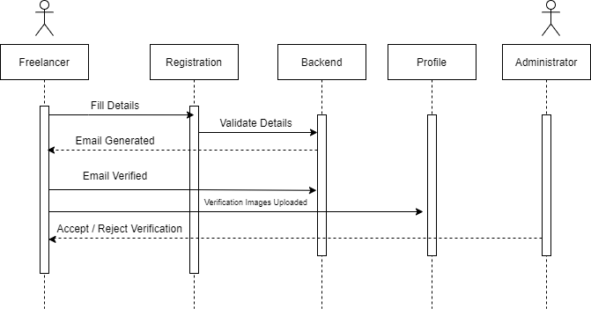

**1.2 Gigs / Job Posting**

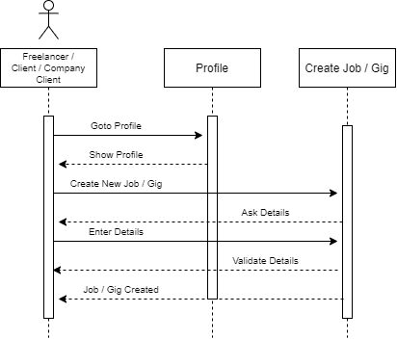

**1.3 Profile Dashboard**

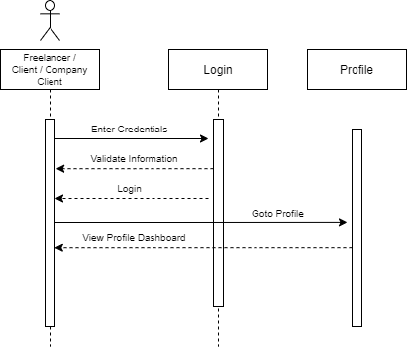

**1.4 Search System**

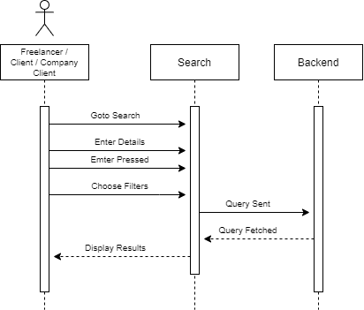

**1.5 Buyer Requests**

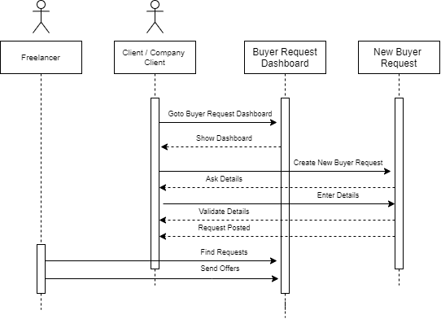

**1.6 Order Management**

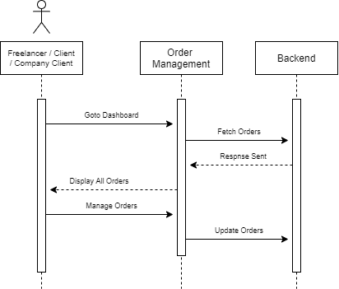

**1.7 Custom Offers**

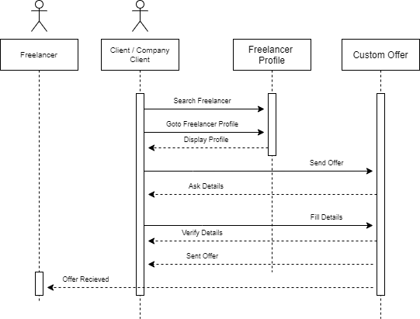

**1.8 Bidding System**

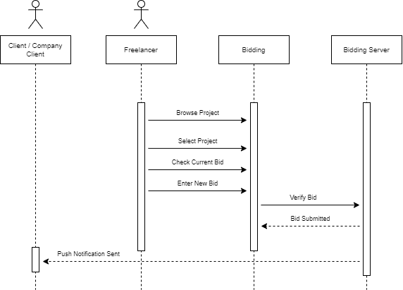

**1.9 Push Notification System**

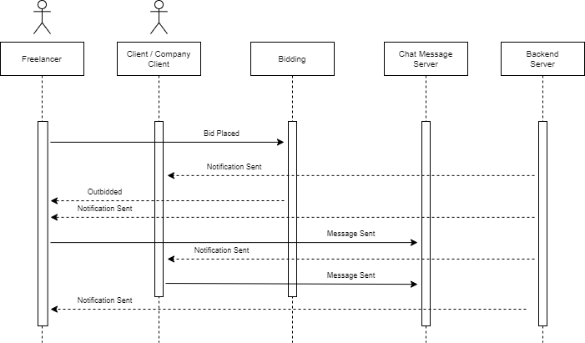

**1.10 Chat Message System**

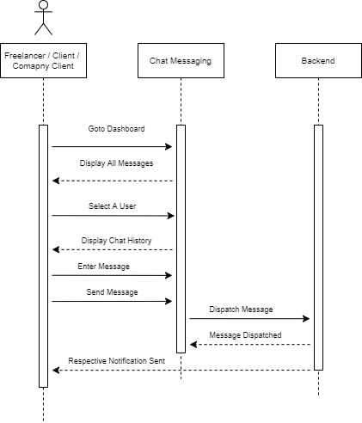

**1.11 Rating / Feedback System**

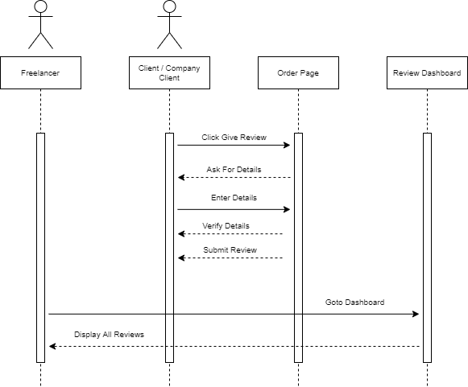

**1.12 Personalized Testing System**

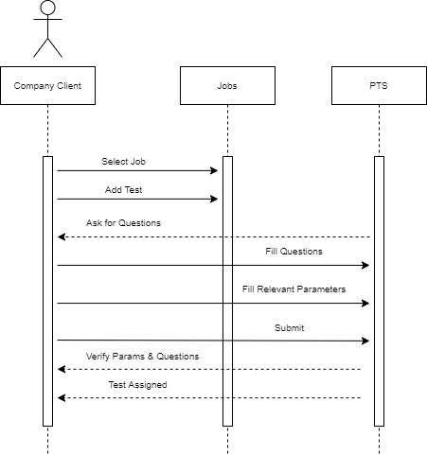

# Software Design Specification

**1. Introduction**

* 1. **Purpose of this document**

The purpose of this document is mainly to break down the product into components to describe in detail what the purpose of each component is and how it will be implemented.

* 1. **Scope of the development project**

We aim to create a platform that targets freelancers with much easier policies and regional service charges. On the other hand, to tackle the issue of unprofessional and unskilled freelancers, we aim to provide a customized filtering process to ensure that only professional and skilled freelancers can be allowed to work on the platform. We also provide a customized test related to the job that is being bided by freelancers so that only matched freelancers can bid on outsourced projects by businesses, as this way we can tackle much of the filtering part we can offer to the clients. To tackle the issue of the order policy we will make sure that the freelancer has the choice to accept or decline customer job offers made by the client.

* 1. 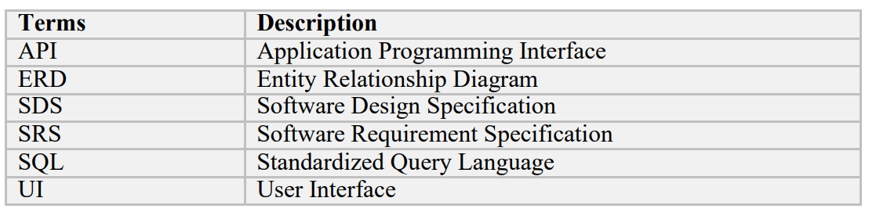 **Definitions, acronyms, and abbreviations**
  2. **References**

IEEE Template for System Design Specification Documents: <https://goo.gl/nsUFwy>

**1.5 Overview of document**

This System Design specification document contains the following information:

**Section 1.0**: An introduction to the document by explaining the purpose of the document, the scope providing terms and references, and a brief overview of each section within the document.

**Section 2.0**: An overview of the system architecture, system components and modules, relationships between the various components, and user interface issues without any technical details.

**Section 3.0**: A detailed description of each software component used in our product.

**Section 4.0**: A detailed description of the user interface including screen images.

**Section 5.0**: An explanation of the reusability of existing products and relationships within the product.

**Section 6.0**: A listing of the design decisions and tradeoffs made during the design phase. This section will help readers and users understand the reasoning for these decisions.

**Section 7.0**: Pseudo code implementation for the different algorithms used in the creation of neural networks and in its training and simulation.

**Section 8.0**: It contains an appendix.

1. **System architecture description**

This section provides an overview and rationale for the program's data and architectural design decisions.

* 1. **Section Overview**

This section describes the constraints and usability of the system. Data design are used to explain the major features of the system.

It describes the complete structure of the software and detail description of each individual features. It also describes the architecture design with major components of the software.

* 1. **General Constraints**

Pakwork, the main thing which is to be kept in mind is to provide flow in the performance of the system. The system will be easy to understand, easy to use, responsive, secure and the most important it will be so simple so that the user can use it smoothly. Website does not need any heavy performance computer normal system can also access this website; however, we do require an internet connection in order to use the website. The project is flexible and can modify any part of the project. This software will work on web platform. There is no more external software which is connected to this software directly or indirectly. The database of the website is placed on MySQL and MongoDB which requires internet connectivity to fetch and store data. The Mailing System is based on Gmail so the SMTP service also requires an internet connectivity for its communication.

* **Hardware Interface:**

Since the tool has no designated hardware and it can run on any computing machine it does not have any direct hardware interface. Although for optimal performance and faster results the user is required to use a high-speed internet.

* **Software Interface:**

The software interfaces that are used in the tool are as follows:

Microsoft Visual Studio Code: Microsoft Visual Studio Code is a lightweight text editor that is widely-used for any particular programming task, mainly it is used for web development. Due to its performance many developers consider it as their daily go-to text editor when they’re programming scripts or applications.

MySQL Workbench: MySQL is a relational database management system developed by Microsoft. As a database server, it is a software product with the primary function of storing and retrieving data as requested by other software applications— which may run either on the same computer or on another computer across a network.

MongoDB: MongoDB is a source-available cross-platform document-oriented database program. Classified as a NoSQL database program, MongoDB uses JSON-like documents with optional schemas.

Communication Interface: The communication between the different parts of the system is important since they depend on each other. However, the most important communication happening in the website is between web-based interface used by the user to communicate with the system and that is locally done.

* 1. **Data Design**
* Reference to: SRS Appendix B: Entity Relation Diagram, Domain Model   
  1. 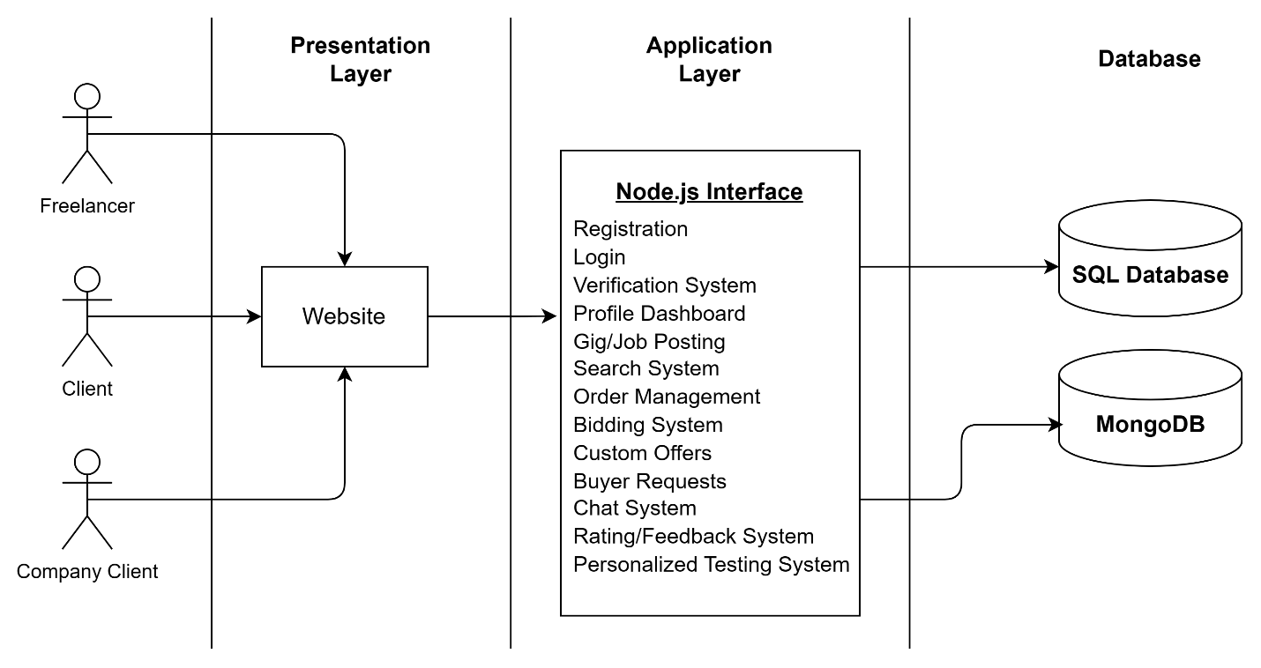**Program Structure**

The major functions the product must perform are listed as follows:

* Freelancer, Client and Company Client would be able to register themselves on the platform
* Freelancer, Client and Company Client would be able to log on to the platform
* Freelancer, Client and Company Client would be able to customize their profile
* Freelancer would be able submit verification documents for verification.
* Freelancer would be able to create, edit or delete Gigs
* Client and Company Client would be able to create, edit or delete custom jobs, requests and offers
* Freelancer, Client and Company Client would be able to chat with each other.
* Freelancer would be able to accept offers sent by Client or Company Client.
* Client and Company Client would be able to start a bid on their project.
* Freelancer would be able to place bids on the projects.
* Freelancer would be able to search for active jobs.
* Client and Company Client would be able to accept the order delivered by Freelancers.
* Freelancers would be able to deliver the order placed by the Client or Company Client.
* Client and Company Client would be able to leave feedback and rate the order.
* Company Client would be able to create any personalized test for the Freelancers.

**2.5 Alternatives Considered**

N/A

**3. Detailed description of components**

This section represents the meat of your document. Be as detailed as time allows.

* 1. **Section Overview**

This section describes the complete description of all components in detailed with their function’s dependencies, their relationships with other components. It describes the interface of each component with input and output requirements.

**3.2 Component of Gigs & Jobs Feature:**

**3.2.1 Description:**

Creating Gigs and Jobs is the most important feature of our application because that’s how the whole process of freelancing would work out, the freelancer makes their gig and the buyer puts out a job that matches the suitable gigs.

**3.2.2 Data Members:**

* **Include Type:** Gigs allow clients to see potential freelancers for their work according their gig description and jobs allow freelancers to match their appropriate buyer according to their job description
* **Visibility:** Gigs are publicly viewable for all while jobs are only available to freelancers and clients who posted that job.
* **Description:** Freelancer can make gigs and clients can view them and communicate with them, clients can post jobs and freelancers can view them and send particular offer to the client.

**3.2.3 Methods**

|  |  |
| --- | --- |
| Identification | The Gigs/Jobs component can be accessed by the freelancers and clients to interact on the platform. It is located on the dashboard for the appropriate user |
| Type | It is a module having several sub components |
| Purpose | The freelancer makes their gig and the buyer puts out a job that matches the suitable gigs. |
| Function | Freelancer can make gigs and clients can view them and communicate with them, clients can post jobs and freelancers can view them and send particular offer to the client. |
| Subordinates | Gig id, Job id and username are used to differentiate between gigs and jobs creators |
| Dependencies | This component depends on the user provided details and further used in different ways in the system. User can use this component on website. |
| Interfaces | The user interface of course feature is situated in the user profile page. SQL queries is used to connect the interfaces. And the code which is running on back-end implements sessions which means user session will maintain automatically and user can view data according to the gig id or job id. |
| Resources | Database access and External APIs permissions is required to run this component. |
| Processing | Gigs and Jobs will be created and freelancers, clients can interact with them. |
| Data | This Component will store related Gigs and Jobs data inside the database. |

**3.3 Component of Order Management and Rating/Feedback:**

**3.3.1 Description**

Order management and Rating/Feedback are one of the most important features in our application because with their interaction the client and freelancer can have a secured business on the platform without any 3rd Party involvement.

* + 1. **Data Members**
* **Include type**

Clients will place an order on a particular offer made by the freelancer and the order will be started. Freelancers would have to deliver the order by sending the necessary content within the time or else they will be penalized for that. After the delivery the client has to accept the delivery or request for changes and leave feedback once the order is completed with a rating as well.

* **Visibility:**

Order management is only visible to the freelancer and the client, the rating system will be available to the client while the freelancer can only view the given rating and feedback.

* **Description**

Clients can place the order from the offers sent by the freelancers and start the order and mark it complete once it’s delivered by the freelancer.

**3.3.3 Methods**

|  |  |
| --- | --- |
| Identification | The order component can be accessed by the freelancers and clients to interact on the platform. It is located on the dashboard for the appropriate user and the rating/feedback component will be appeared after the completion of the order |
| Type | It is a module having several sub components |
| Purpose | Clients can place the order from the offers sent by the freelancers and start the order and mark it complete once it’s delivered by the freelancer. |
| Function | Clients will place an order on a particular offer made by the freelancer and the order will be started. Freelancers would have to deliver the order by sending the necessary content within the time or else they will be penalized for that. After the delivery the client has to accept the delivery or request for changes and leave feedback once the order is completed with a rating as well. |
| Subordinates | Order id and usernames are used to differentiate between different orders. |
| Dependencies | The Order Component is dependent on the freelancer’s given offer and the feedback/rating component is dependent on the order that has been completed. |

.

|  |  |
| --- | --- |
| Interfaces | The user interface of the order component is accessible from the dashboard and then clicking a particular order and the rating/feedback component will be displayed on that order if the client is viewing. |
| Resources | Database access and External APIs permissions is required to run this component. |
| Processing | Orders and Rating/Feedback will be created and freelancers, clients can interact with them. |
| Data | This Component will store related Order and Feedback/Rating data inside the database. |

**4. User Interface Design**

**4.1 Section Overview**

This section provides a view into the set of standards which we have made use of to build a user-friendly Pakwork Website. They have been applied in the best possible way to make the interface appear pleasing to the user and not seem too difficult to understand at the same time.

**4.2 Interface Design Rules**

Component Reusability in React.js is to design all web interfaces. Html, CSS and bootstrapping are used to design all website pages. There is no specific standard followed for designing this website. Users should always be informed of system operations with easy to understand and highly visible status displayed on the screen within a reasonable amount of time. Interface designers should ensure that both the graphic elements and terminology are maintained across similar platforms. For example, an icon that represents one category or concept should not represent a different concept when used on a different screen. Designers should assume users are unable to understand technical terminology, therefore, error messages should almost always be expressed in plain language to ensure nothing gets lost in translation.

**4.3 GUI Components**

Pakwork is not planning to use any external APIs for its functionality and plans on building most of its APIs internally. As for its GUI components are concerned, they’re purely built on React, while the email-templates and external verification links are rendered html directly from node-mailer and express-html.

**4.4 Detailed Description**

Registration: Create your account on the platform (freelancer, client, company client)

Login: Sign-in to your accounts (one login for all types of users )

Dashboard: Show profile detail of the user that is logged in according to their user type.

Profile Management: Update Profile Details such as profile picture, description, social links.

Verification System: Upload Documents to verify as a freelancer on the platform.

Gigs Page: Collection of Gigs according to the given searched text.

Gig Detail Page: Show Detail of the selected gig.

Jobs Page: Collection of Jobs according to the given searched text.

Job Detail Panel: Show Detail of the selected job.

Manage Job Panel: Show appropriate options to create, update a job.

Manage Gig Panel: Show appropriate options to create, update a gig.

Search Box: Search for any type of gigs available.

Manage Orders Page: Show details of the orders along with each’s status.

Order Page: Show details of a particular order with appropriate options.

Chat Inbox Message: Interactive chat conversations with specific users.

Live Bidding Page: Shows all active live biddings that are happening.

Live Bidding Room: Show details of a particular bidding with options to interact.

Custom Offer Panel: Create a custom offer with appropriate options.

Buyer Requests Panel: Create a buyer request with appropriate options.

- For Screenshots refer to appendix in the Software Requirement Specifications

**5. Reuse and relationships to other products**

Reusability allows developers to be more efficient because the same code can be developed once and used in many different applications. Second, reliability can be improved by reusing previously developed, and previously tested, components. The development of new code entails additional costs in time and money for testing, validation, and verification. Much of these expenses can be avoided by using already manufactured external components.

# 6. Design decision and tradeoffs

**N/A**

# Pseudocode for components

**N/A**

# Appendices

**8.1 Class Diagram**

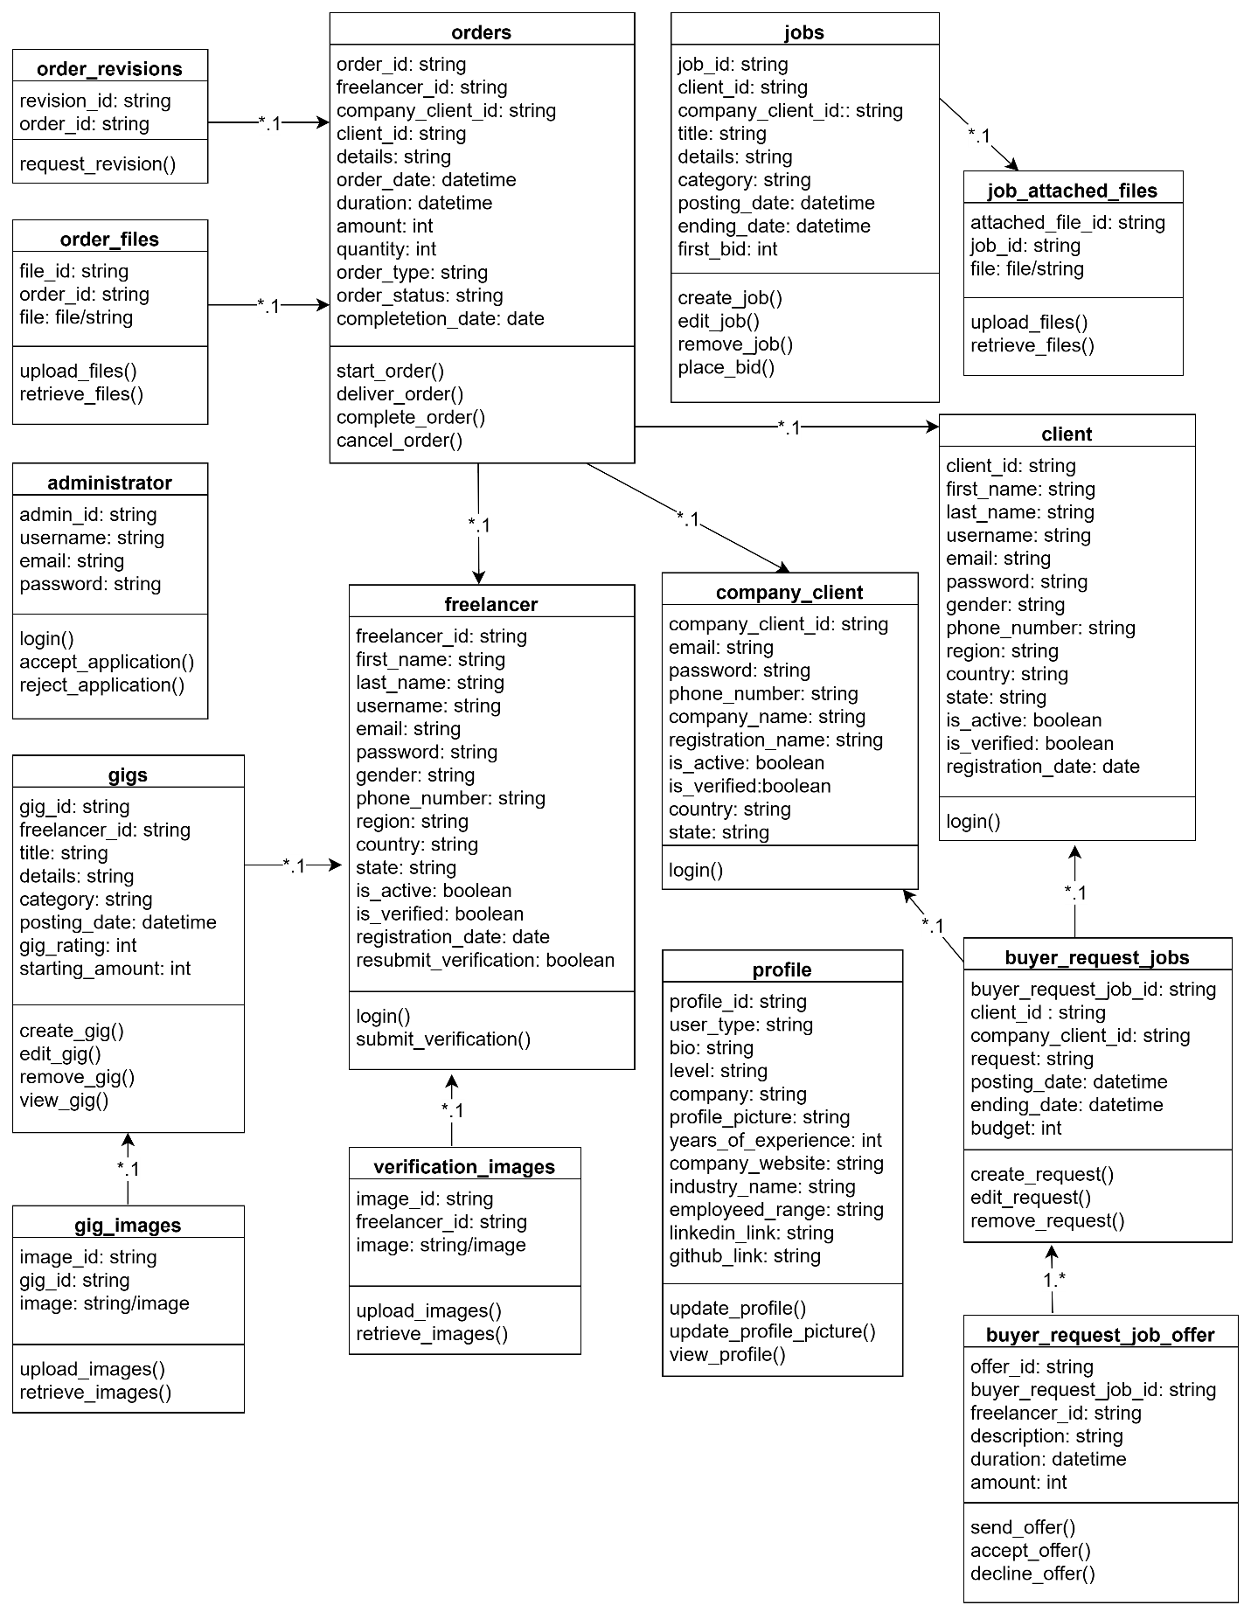

**8.2 Object Diagram**

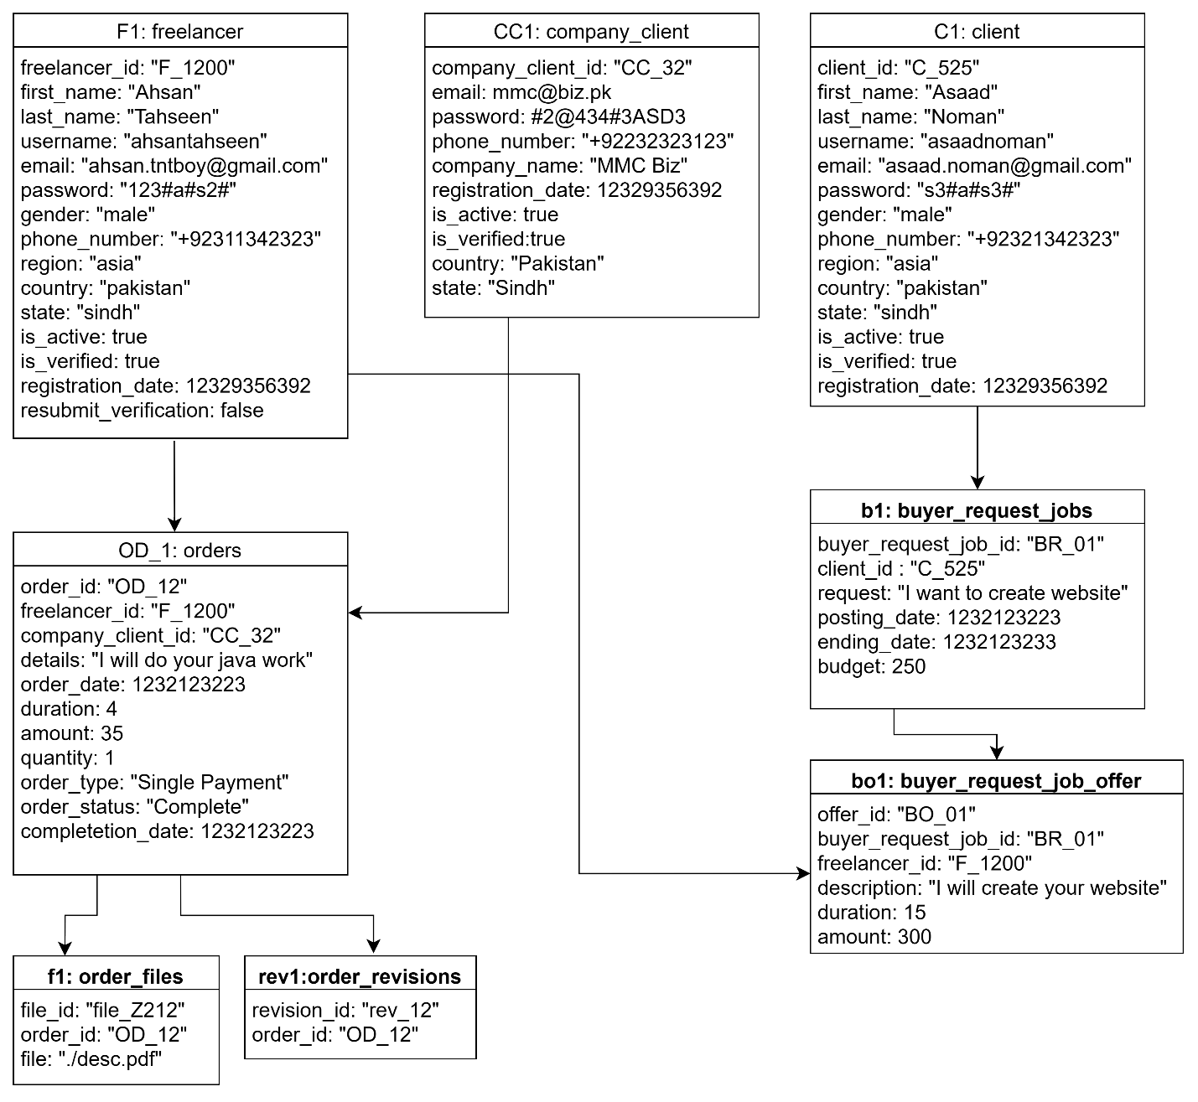

**8.3 Statechart Diagram**

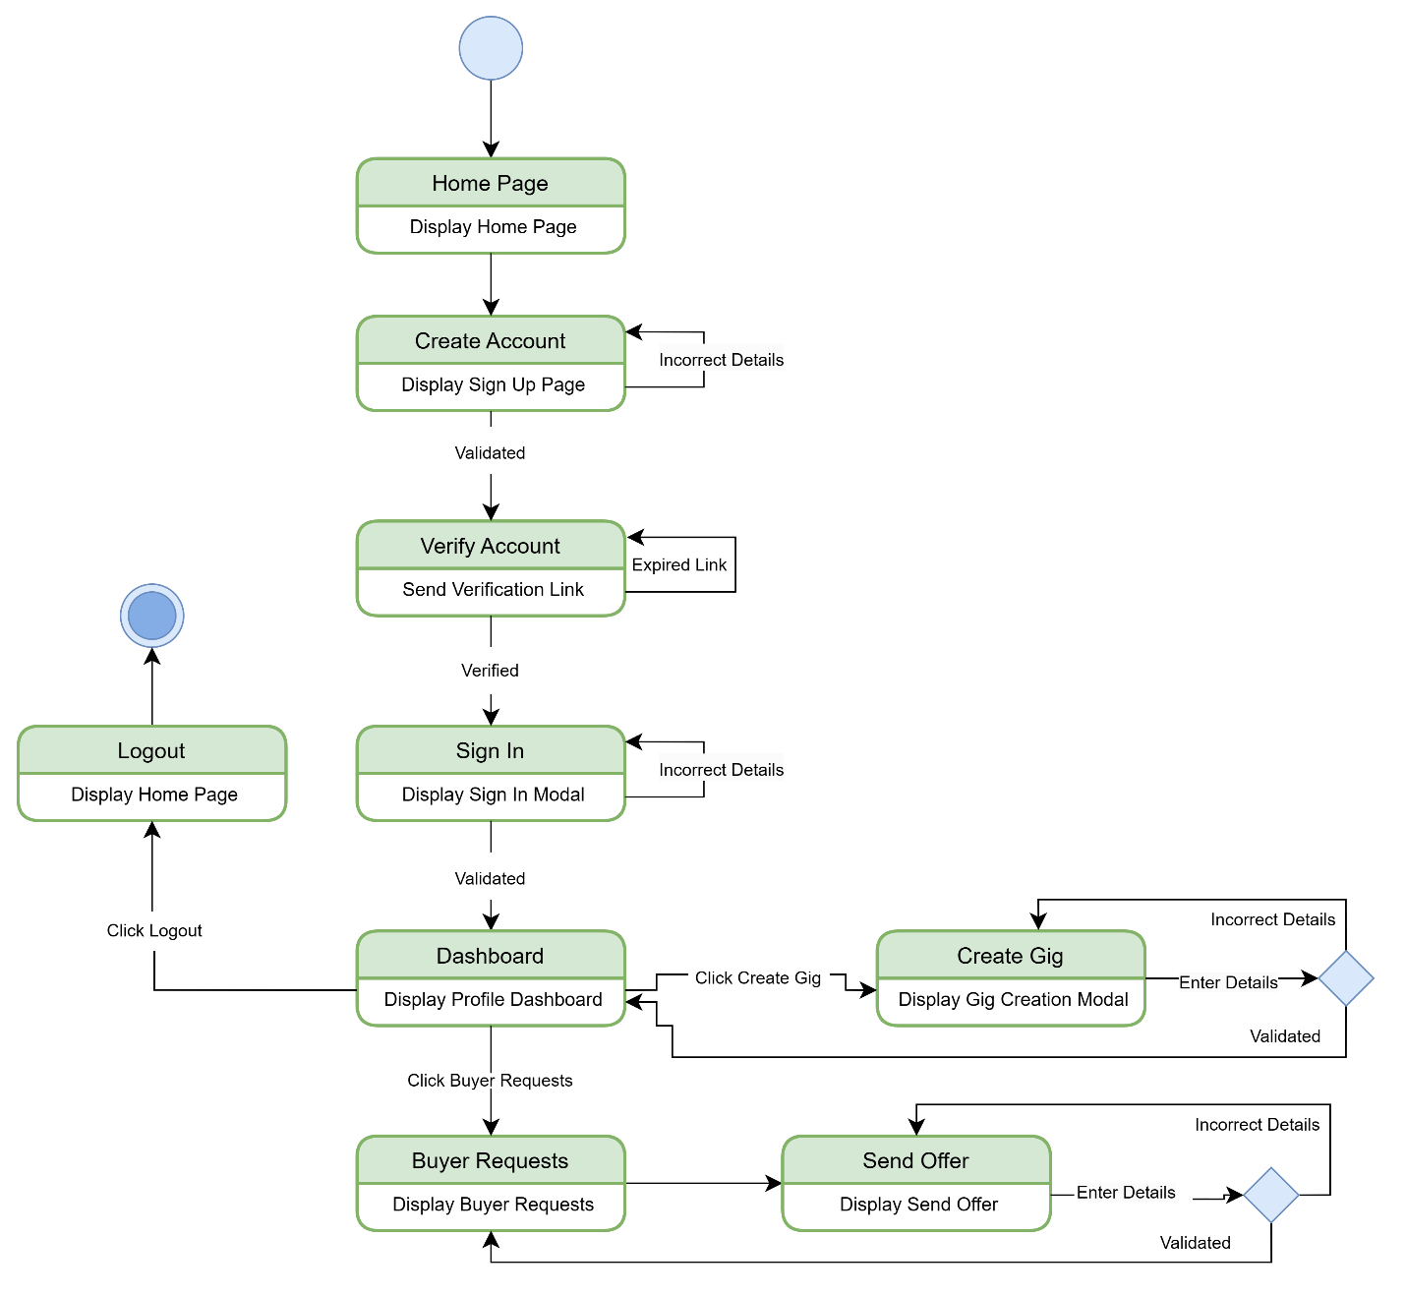

**8.4 Activity Diagram**

**8.4.1 Freelancer Account Verification**

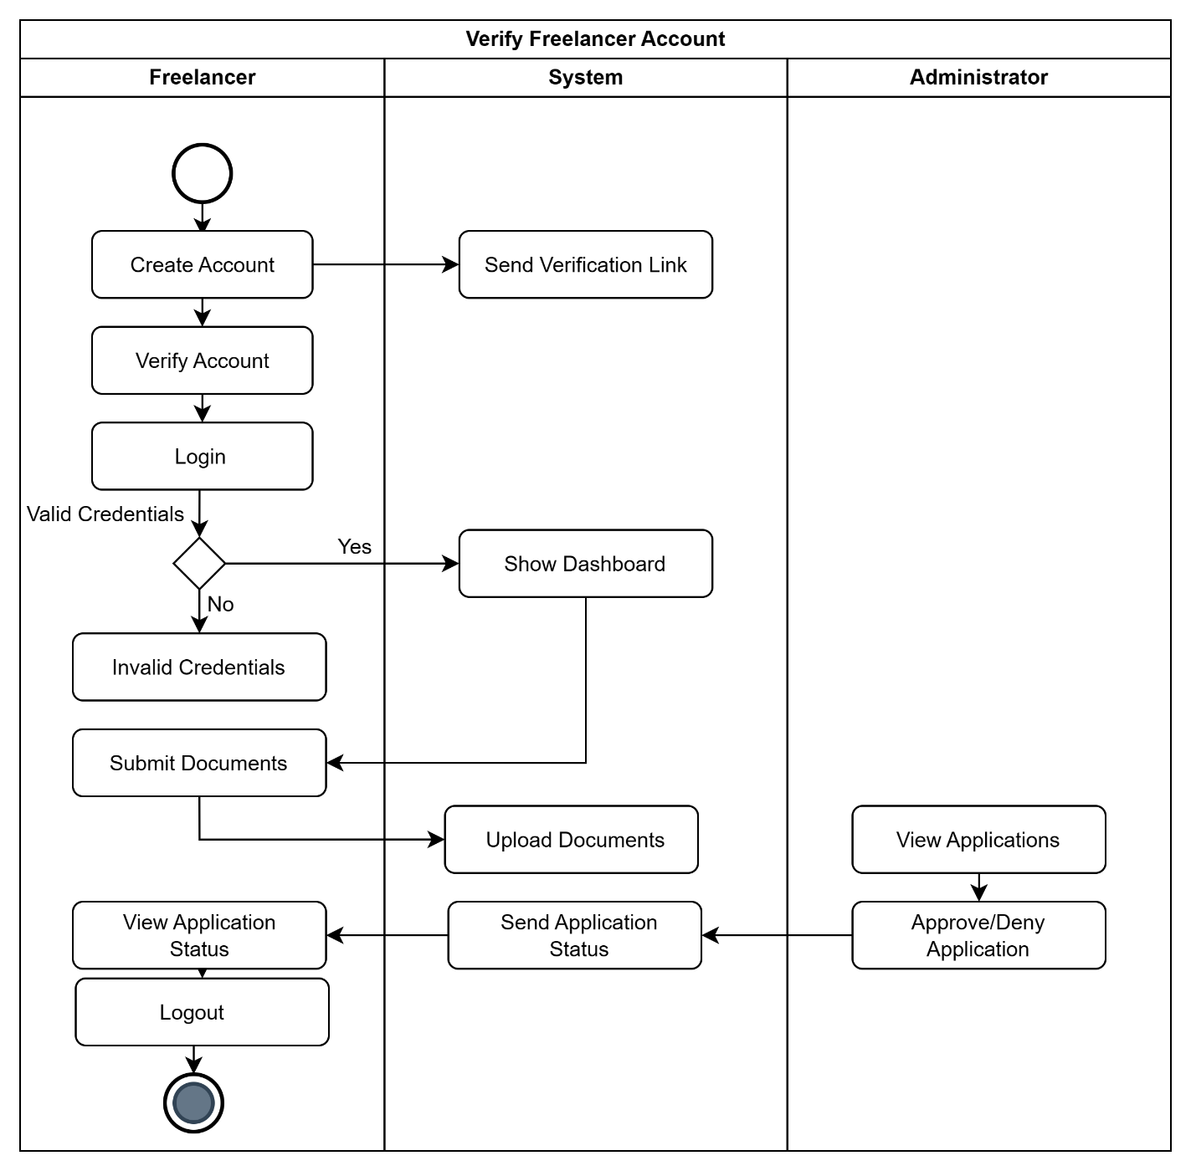

**8.4.2 Gig / Job Creation & Posting**

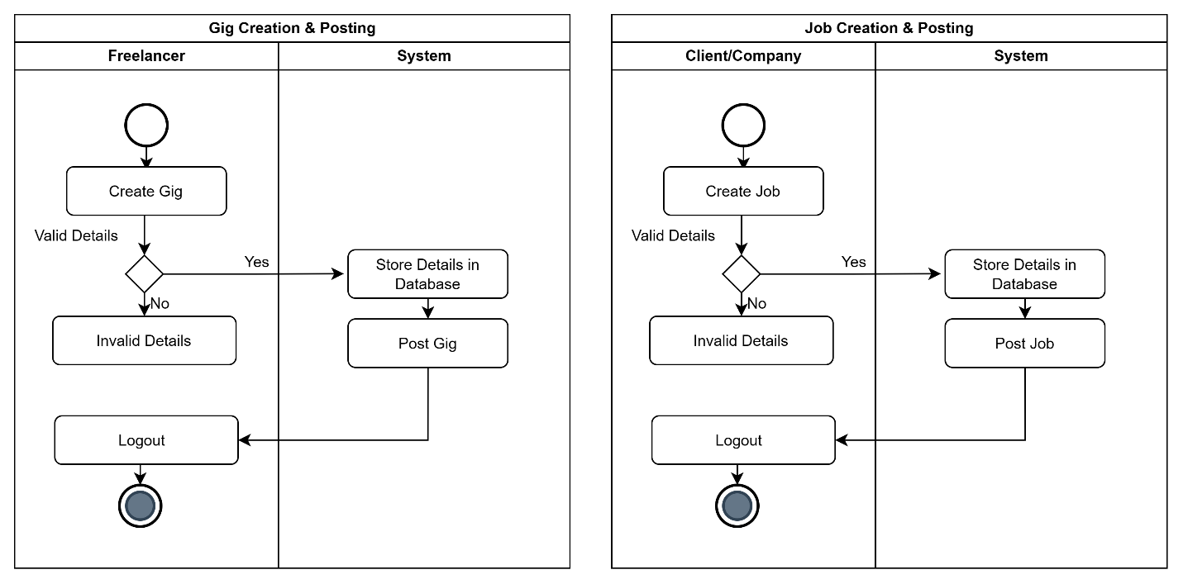

**8.4.3 Search System**

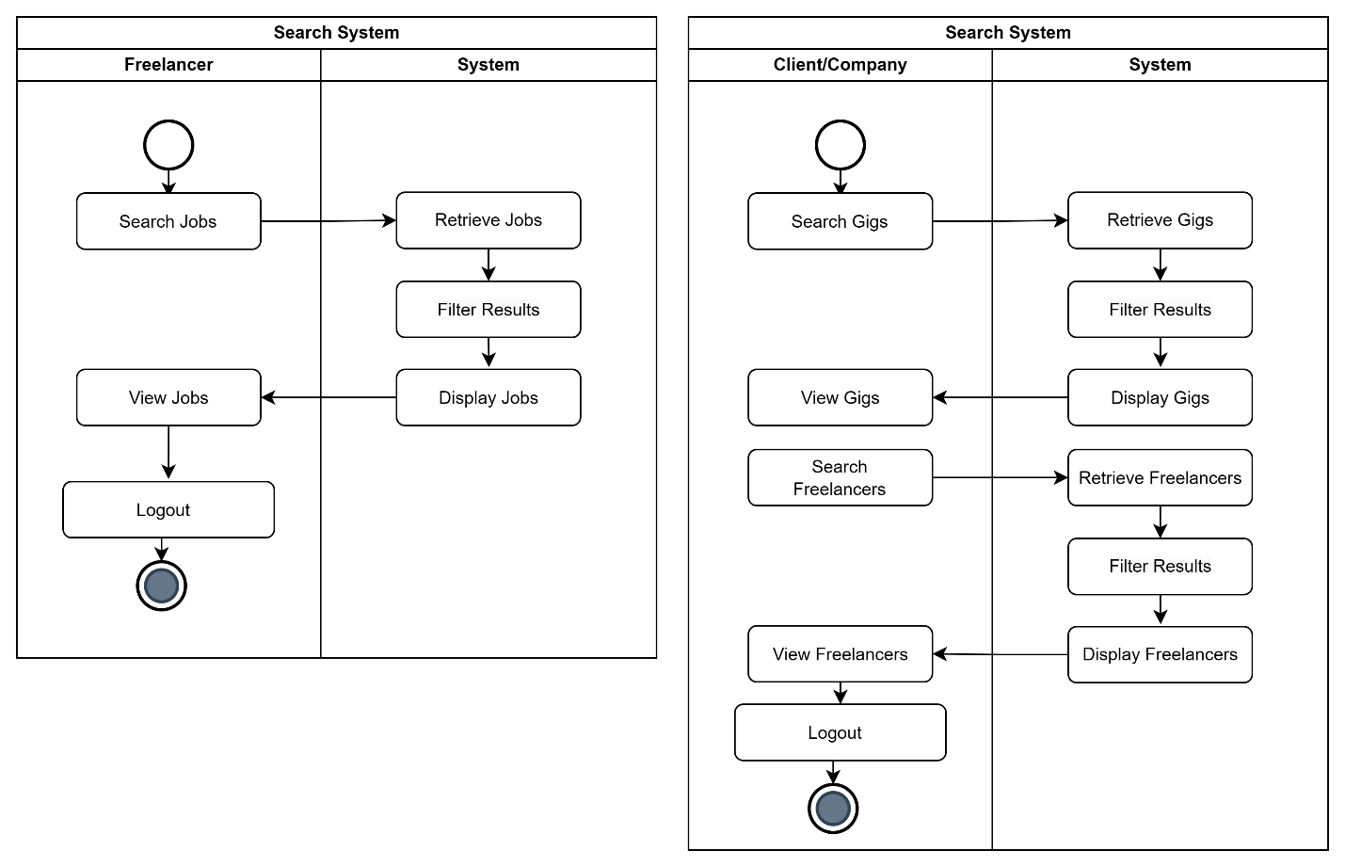

**8.4.4 Profile Dashboard**

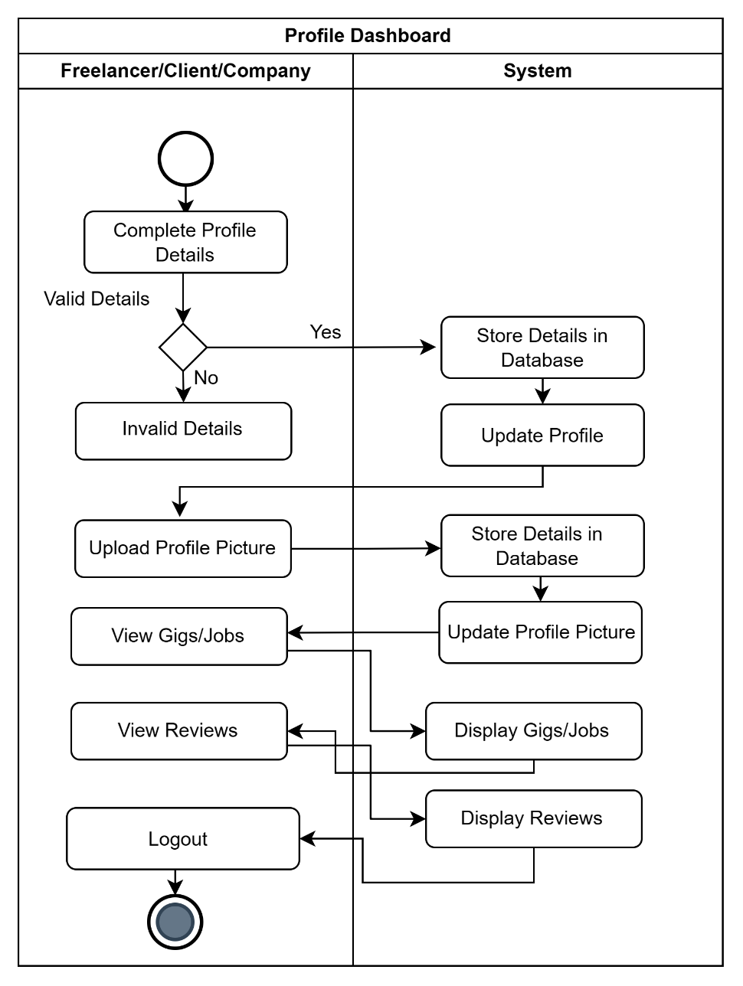

**8.4.5 Buyer Request**

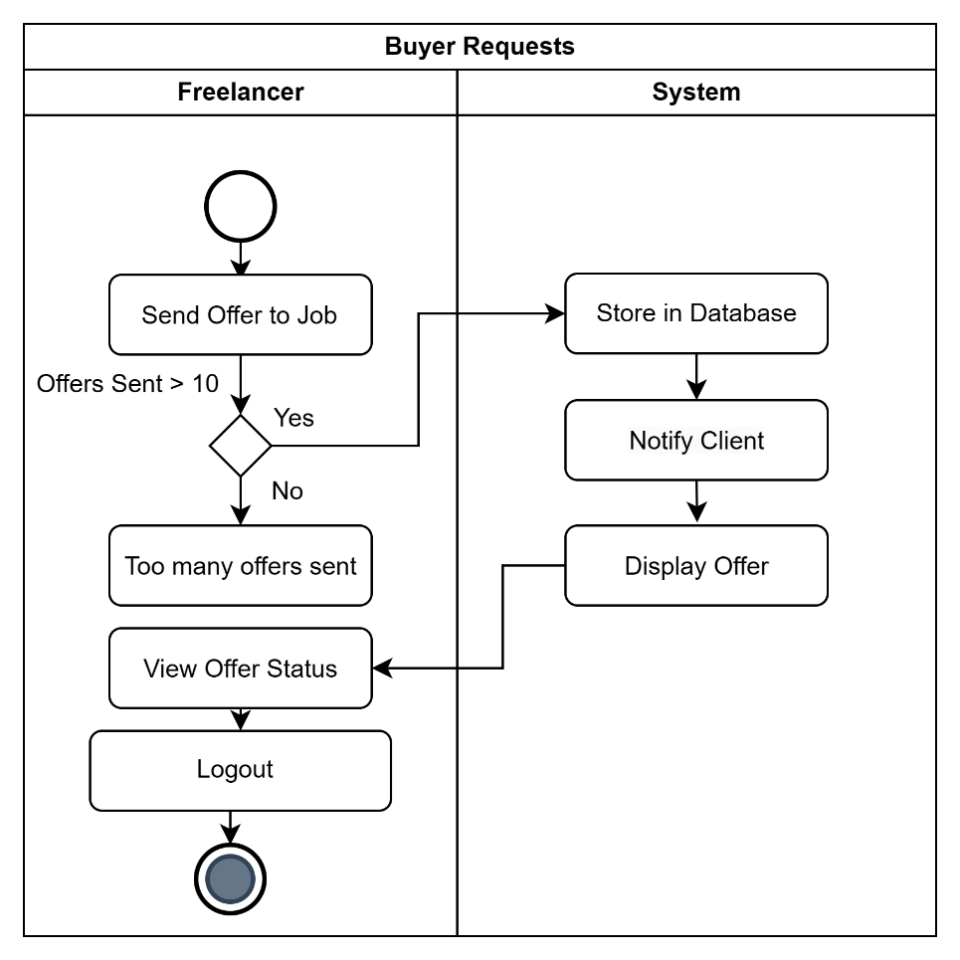

**8.4.6 Order Management**

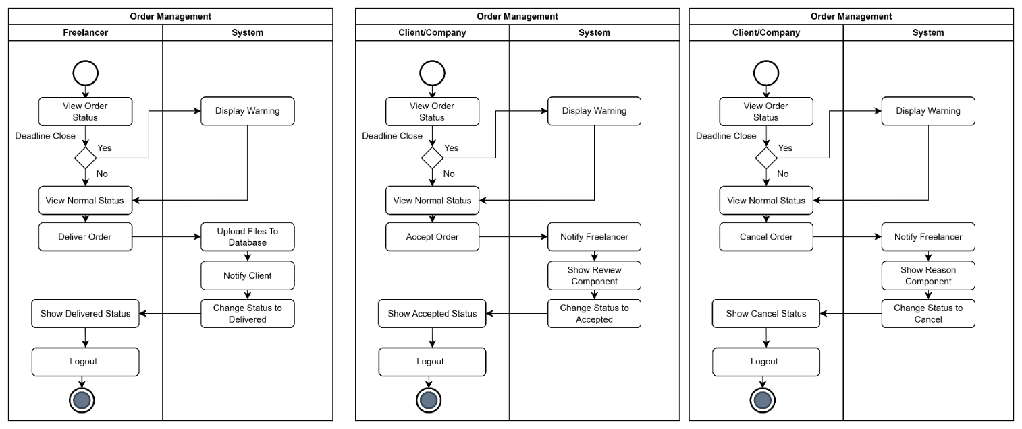

**8.4.7 Custom Offers**

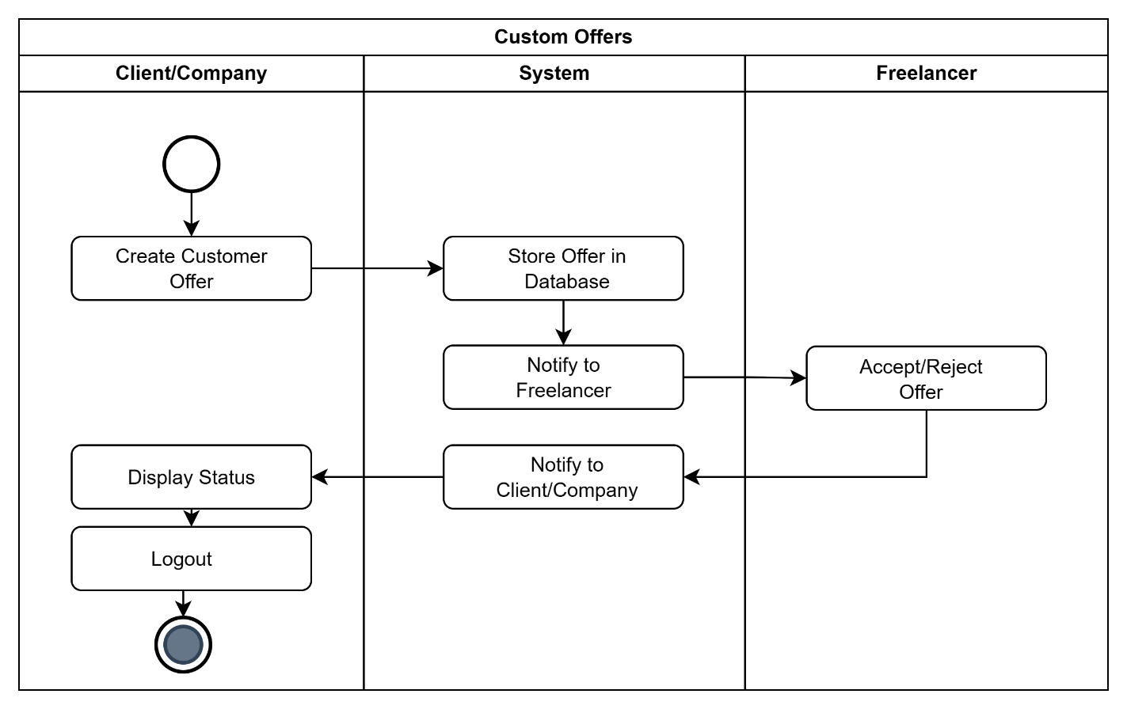

**8.4.8 Bidding System**

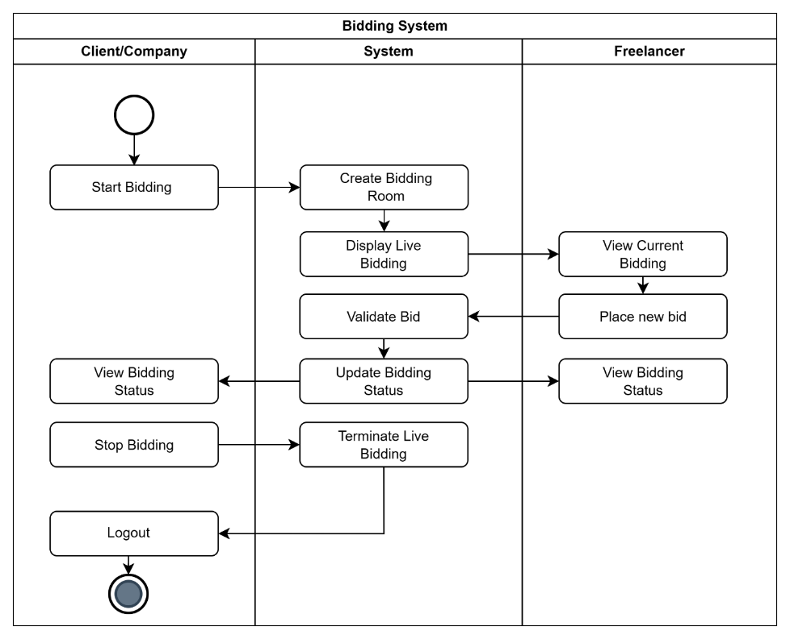

**8.4.9 Push Notification System**

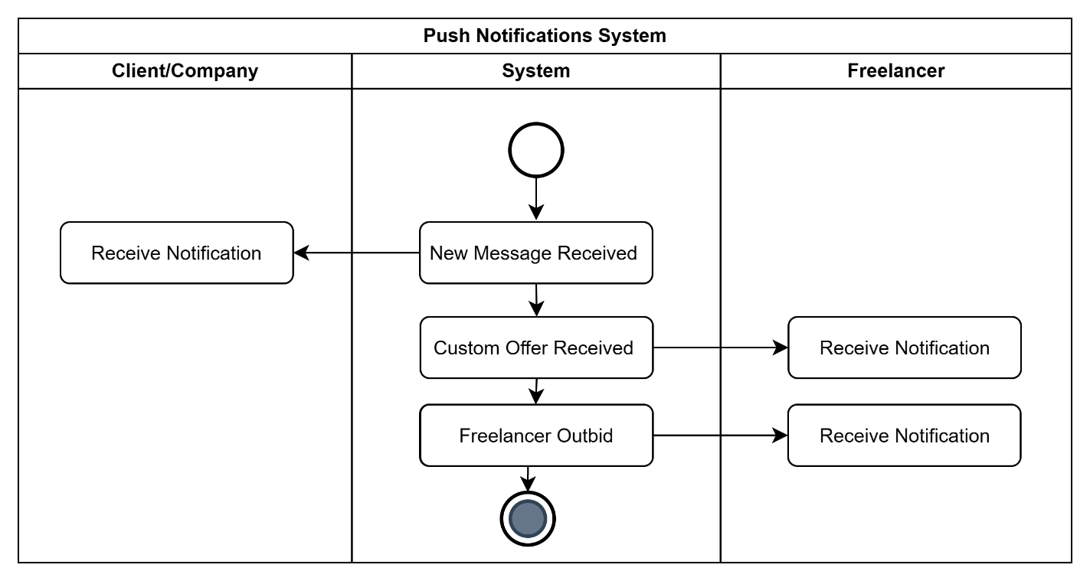

**8.4.10 Chat System**

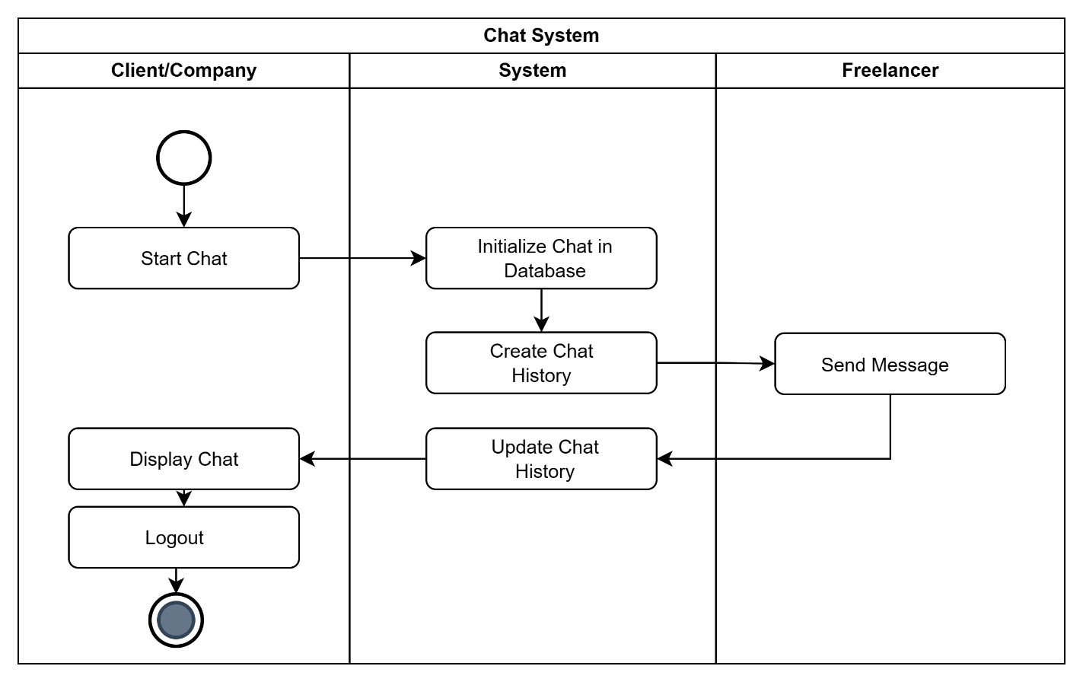

**8.4.11 Rating/Feedback System**

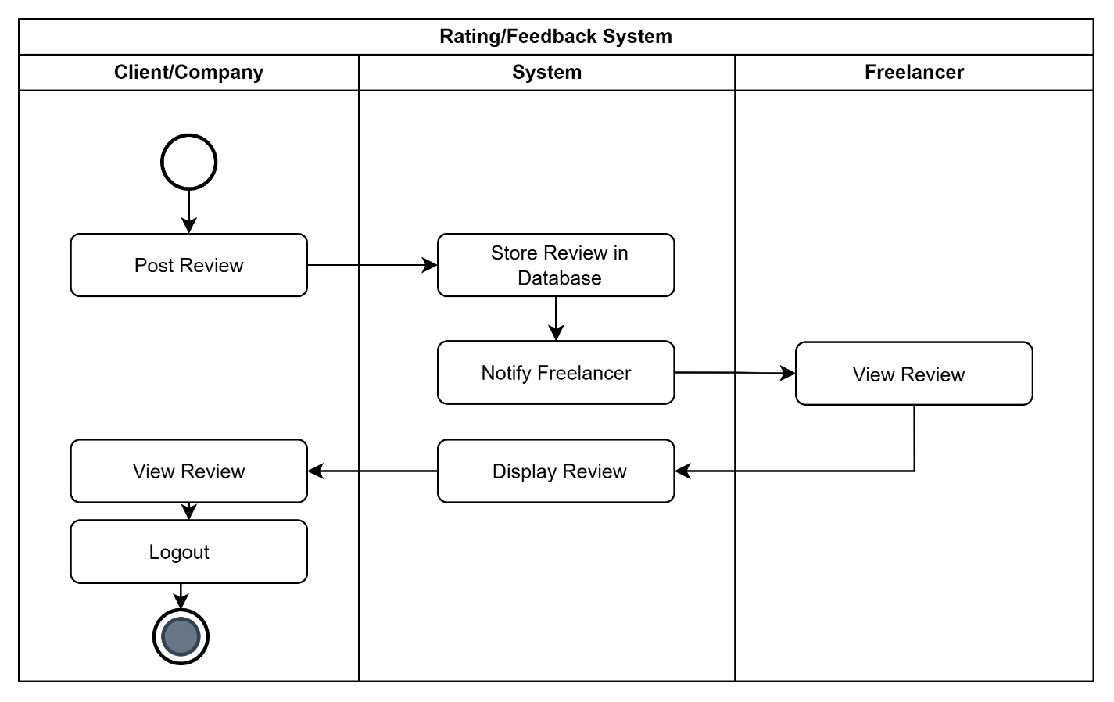

**8.4.12 Personalized Testing System**

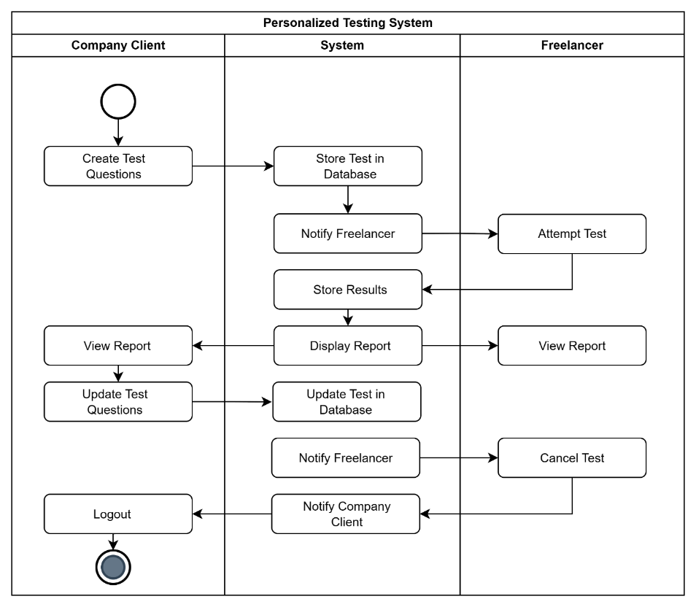

**8.5 Sequence Diagram**

Refer to Appendix in System Requirements Specification or Page 68

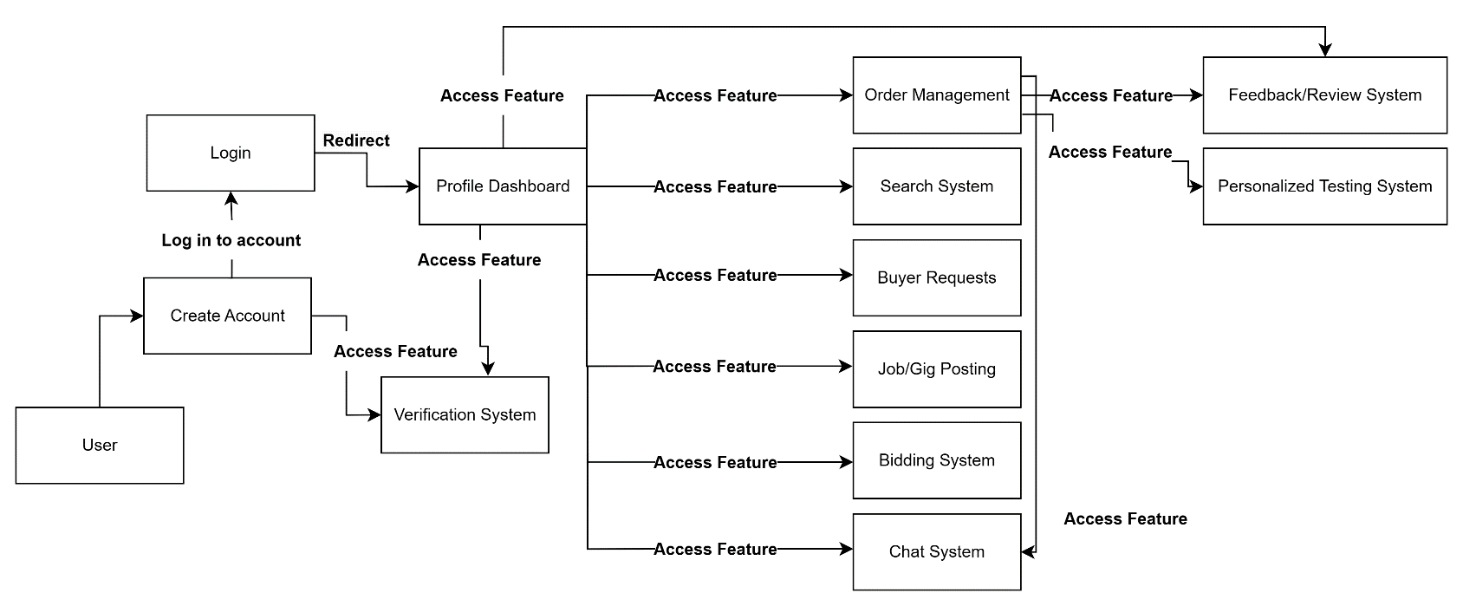**8.6 Collaboration Diagram**

**8.7 Use Case Diagrams**

Refer to Appendix in System Requirements Specification

**8.8 Component Diagram**

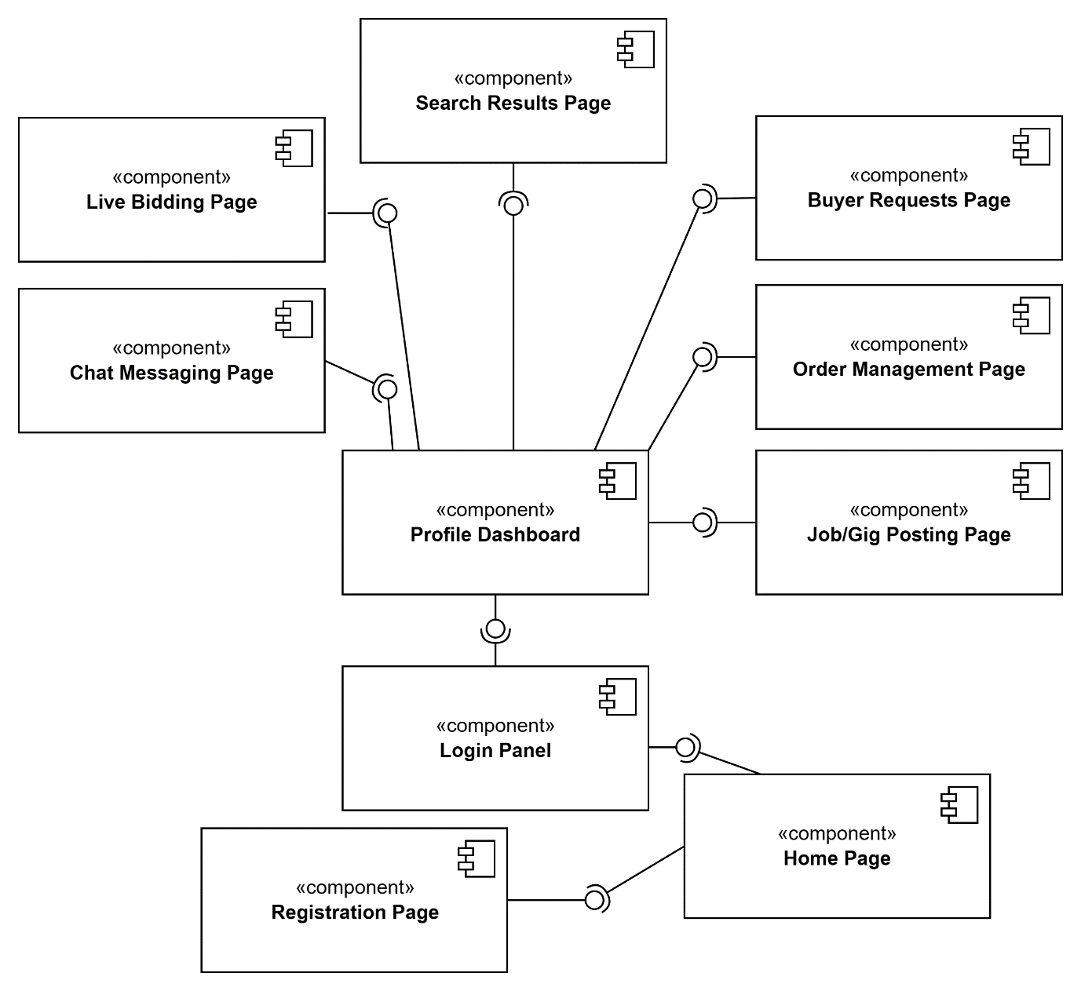

**8.9 Deployment Diagram**

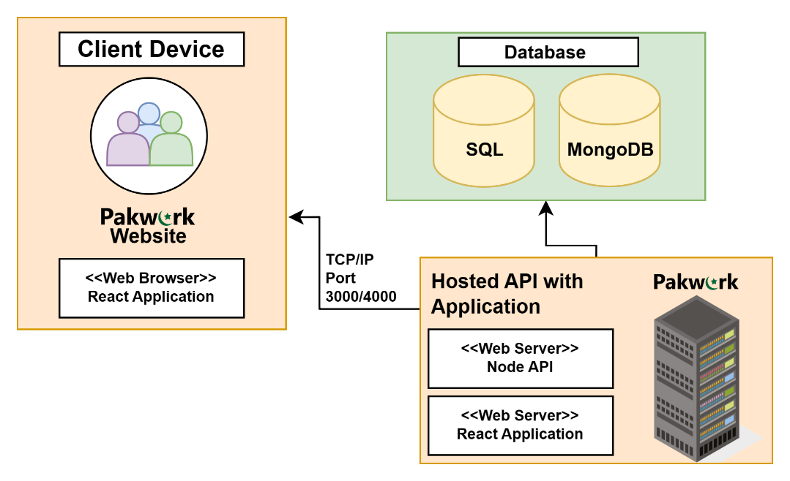

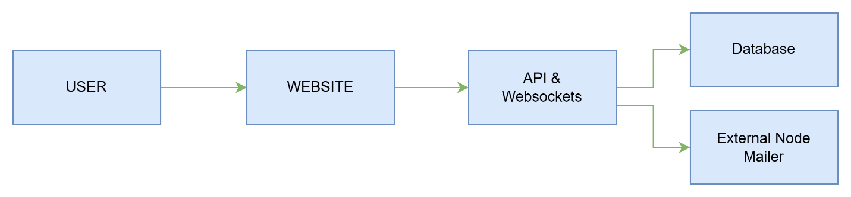**8.10. System Block Diagram**

# User Manual

## General Information

### Project Scope

### We aim to create a platform that targets freelancers with much easier policies and regional service charges. On the other hand, to tackle the issue of unprofessional and unskilled freelancers, we aim to provide a customized filtering process to ensure that only professional and skilled freelancers can be allowed to work on the platform. We also provide a customized test related to the job that is being bided by freelancers so that only matched freelancers can bid on outsourced projects by businesses, as this way we can tackle much of the filtering part we can offer to the clients. To tackle the issue of the order policy we will make sure that the freelancer has the choice to accept or decline customer job offers made by the client.

### Web Application

##### **9.1.2.1 Website**

**9.1.2.1.1 Admin**

* + - Login/Logout
    - Approve/Reject Freelance Verification

**9.1.2.1.2 Freelancers**

* + - Login/Logout
    - Sign Up
    - Reset Password
    - Edit Profile
    - Post Gigs
    - Accept Jobs
    - Deliver Orders
    - Place Bids
    - Send Private Messages

**9.1.2.1.3 Clients**

* + - Sign Up
    - Login/Logout
    - Reset Password
    - Edit Profile
    - Post Jobs
    - Post Custom Offers
    - Place Orders
    - Create Personalized Custom Assesments
    - Send Private Messages

# 9.1.3 Authorized Use Permission

Only the registered admins, client and freelancers are authorized to access the application

# 9.2 System Summary

System summary section provides the general overview of the system, the summary outlines

the use of system’s hardware and software requirements, system’s configurations, user access

levels and system’s behavior, in case of any contingencies

**9.2.1 System Overview**

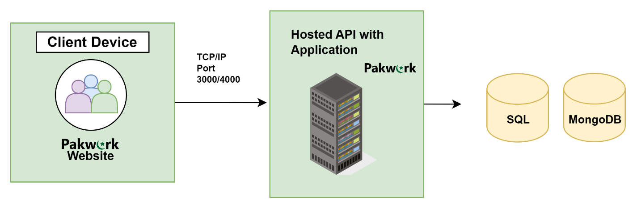The system is built on industry standard, three-tier web architecture, it consists of a multi-database model combining MySQL and MongoDB connected to a RESTful and WebSocket application made with Nodejs and served to an React Web Application

**9.2.2 User Access Level**

Users which have made account on application are able to use app and save data and operate

other functions.

**9.2.3 Contingencies**

Regular backup should be performed, due to the fact that in the event of an emergency and/or accidents, stored data could become lost.

# 9.3 System Features Web Application

## 9.3.1 Home Page

1. How the platform work link.
2. Categories for different gig types
3. Sign Up for Organizational Clients
4. Sign In (Login)
5. Sign Up for Regular Clients
6. Sign Up for Freelancers
7. Search Gig based on keywords

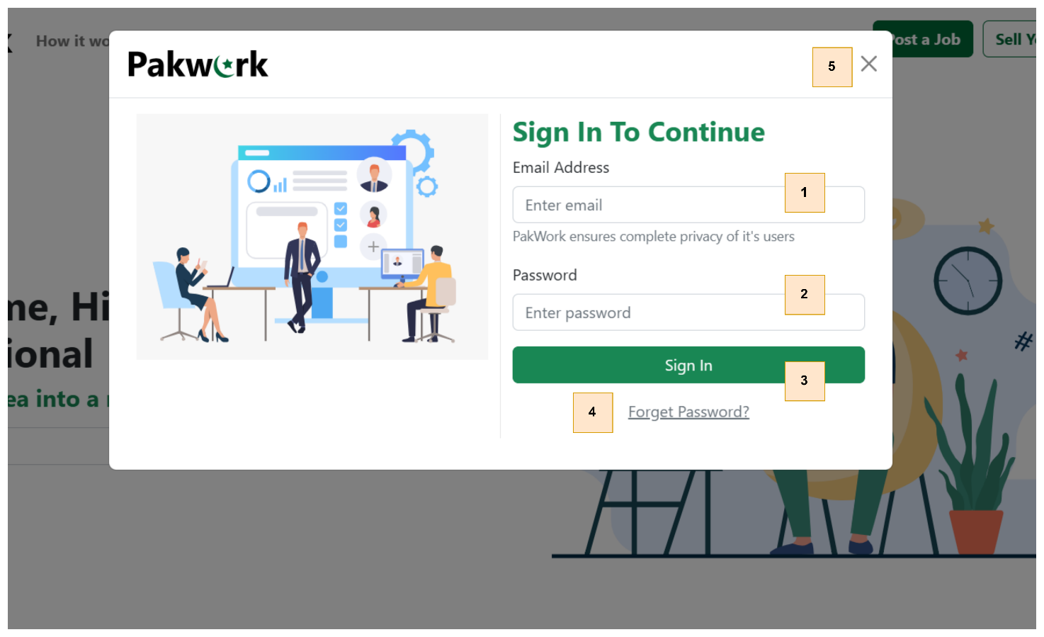**9.3.2 Login Modal**

1. Email Address Input for registered email of the user
2. Password Input for the correct password of the user
3. Sign In Button to continue the process of authentication
4. Forget Password which sends a password link to the registered email
5. Close Button to close the pop-up

## 9.3.3 Sign Up Page

1. First Name Input for Registration

2. Last Name Input for Registration

3. Gender Selection for Registration

4. Date of Birth Picker for Registration

5. Region/Continent Selection for Registration

6. Country Selection for Registration

7. State Input for Registration

8. Email Address Input for Registration

9. Phone Number Input for Registration

10. Username Input for Registration

11. Password Input for Registration

12. Submit Button to process the registration submission for completion

# 9.3.4 Profile Dashboard (Freelancer)

1. Check any available buyer requests for the freelancer
2. Check any jobs for the freelancer to bid on and accept
3. Manage current, past orders of the freelancer
4. Chat Option to communicate privately with users on the platform
5. Profile Button to redirect to the profile dashboard
6. Sign Out Button to logout of the account
7. Upload new profile picture options
8. Edit other profile details like (Bio, Linked Accounts etc.)
9. Create a new gig option
10. View Gig Details
11. Edit Gig Details
12. Delete Gig

# 9.3.5 Profile Dashboard (Client)

1. Search Gigs based on keywords
2. Manage current/past orders that were placed by the client
3. Chat Option to communicate privately with users on the platform
4. Profile Button to redirect to the profile dashboard
5. Sign Out Button to logout of the account
6. Post a Job with requirements and an option to add skill-based test for bidders.
7. Post a Custom Offer Request with requirements without any skill-based tests or bidding.
8. View all offers given by the freelancer
9. Edit the Request Details
10. Delete Request
11. Upload new profile picture options
12. Edit other profile details like (Bio, Linked Accounts etc.)

## 9.3.6 Create Custom Offer Request (Client)

1. Title or Headline of the Custom Offer Request
2. Detailed Description of the Custom Offer Request
3. Budget of the Custom Offer Request
4. Duration of the work in the Custom Offer Request
5. Submission Button to create the Custom Offer Request

# 9.3.7 Create Gig (Freelancer)

1. Title / Headline Input of the Gig
2. Gig Category Selector in which it belongs to
3. Starting Price of the Gig from this price it starts its services
4. Detailed Description of the Gig
5. Images of the Gig for the showcase of the search results
6. Submission Button to create the Gig

# 9.3.8 Order Page

1. Order Duration Timer which shows how much time is left before the order goes overdue
2. Order Description which mentions a detailed description of the client’s requirements
3. Order Details and Status which gives basic information of the order like amount, date for the delivery and unique identification of the order
4. File Dropzone for the order delivery files that freelancer can upload to, for delivering the order.

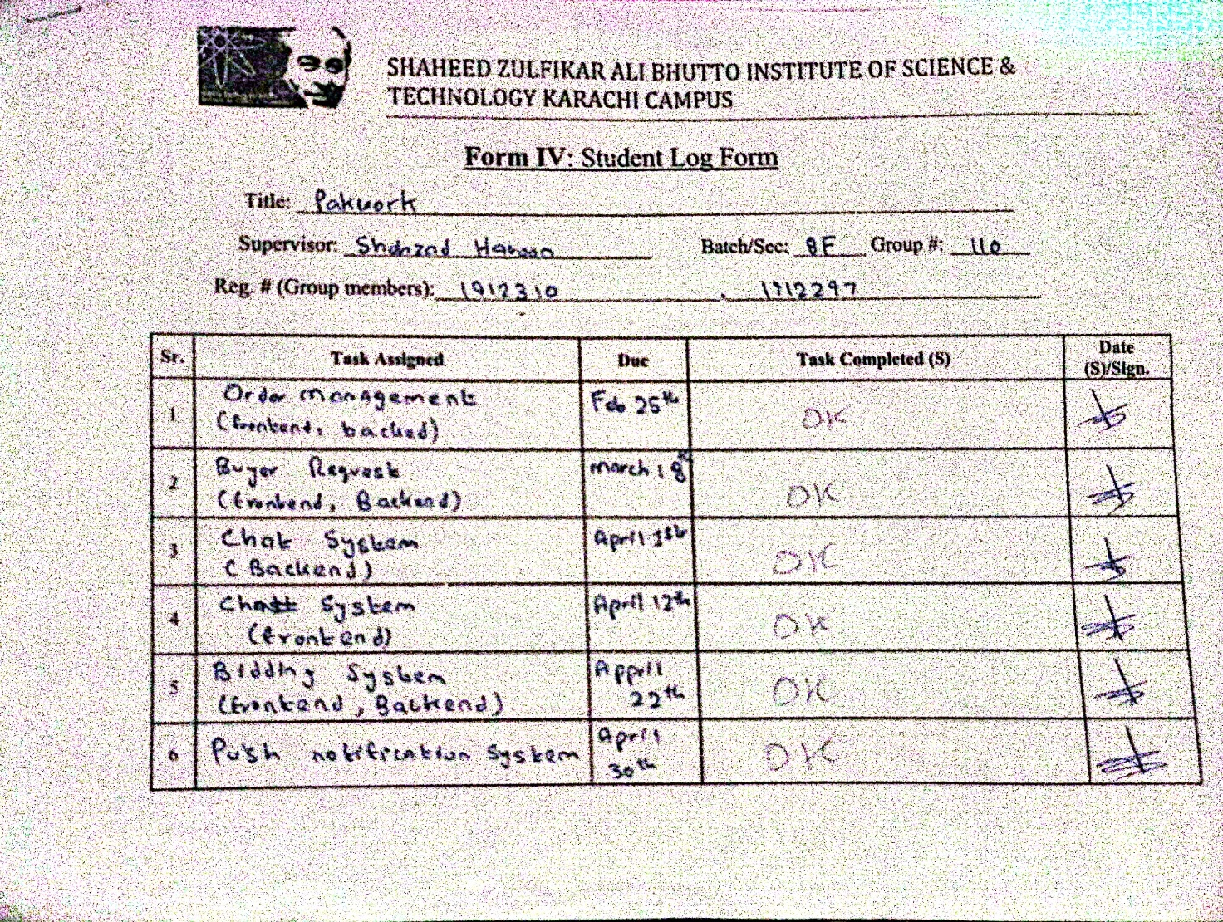**10. Meeting Log Sheet**